**Deep Learning in Python**

#### Basics of deep learning and neural networks



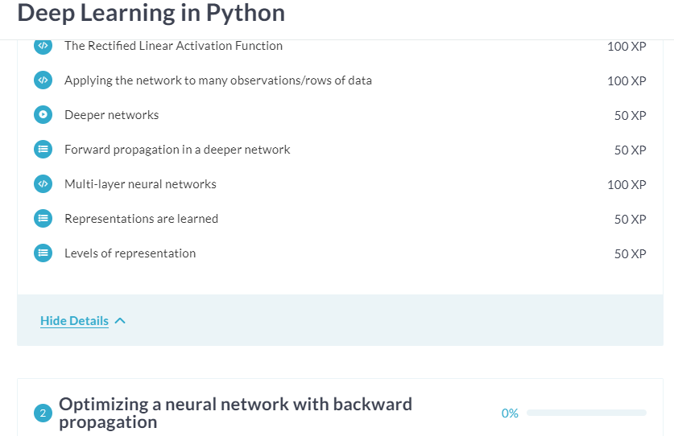



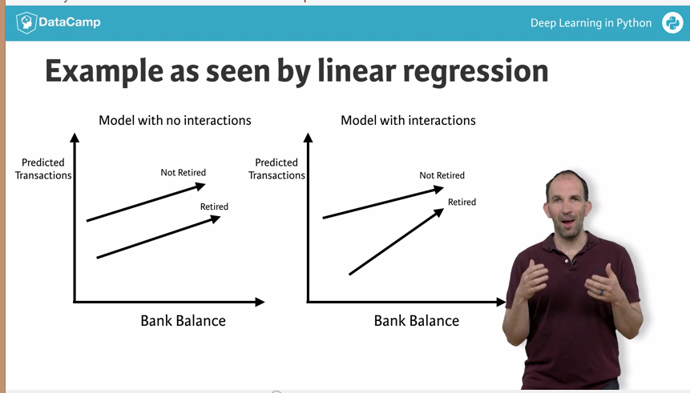

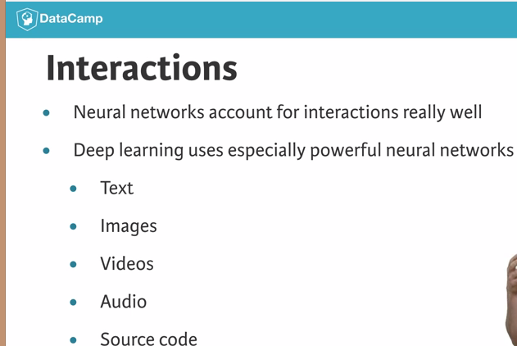

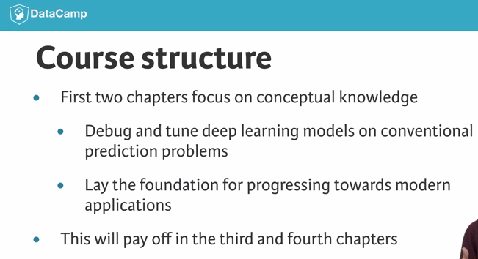

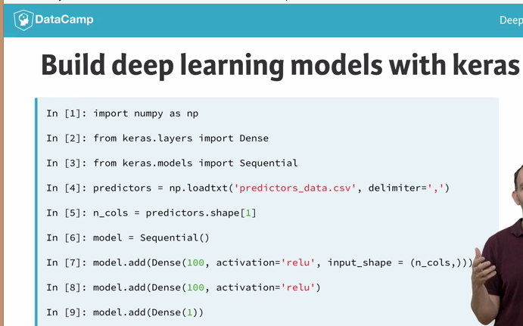

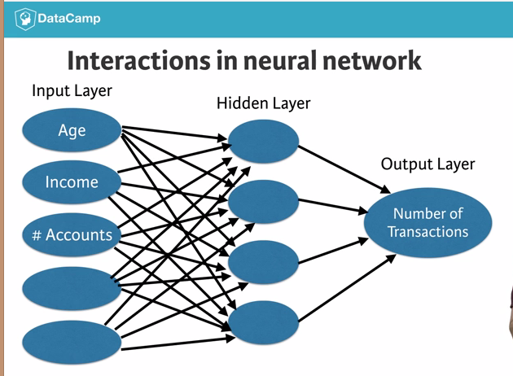

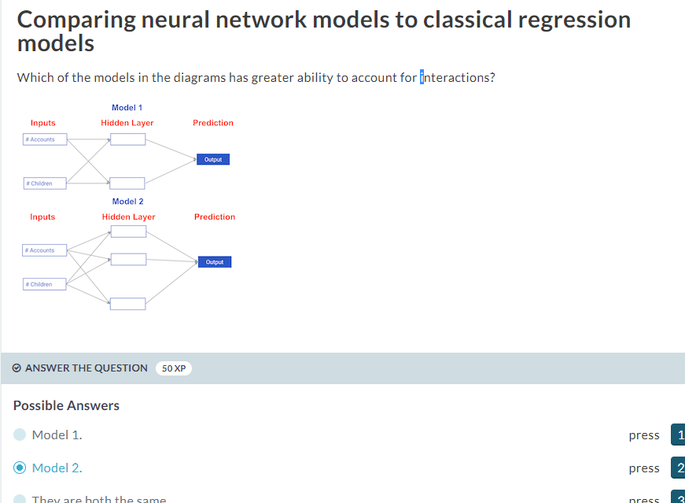



# Forward propagation

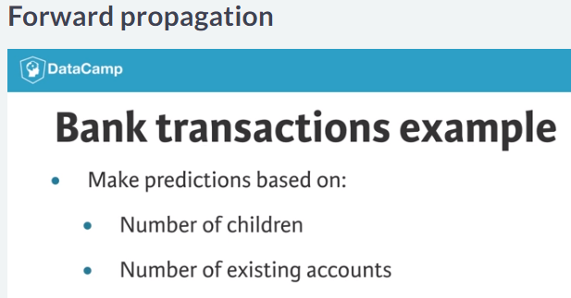

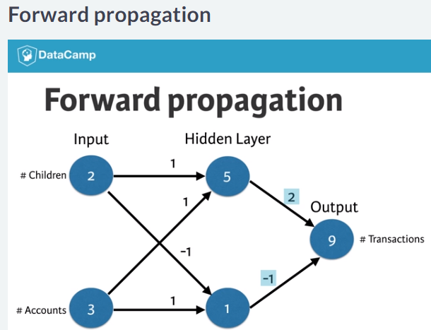

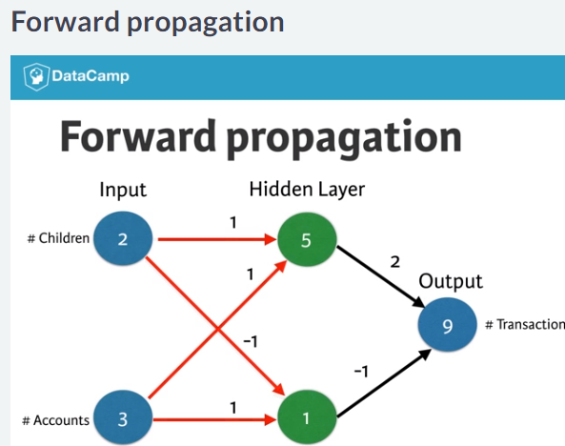

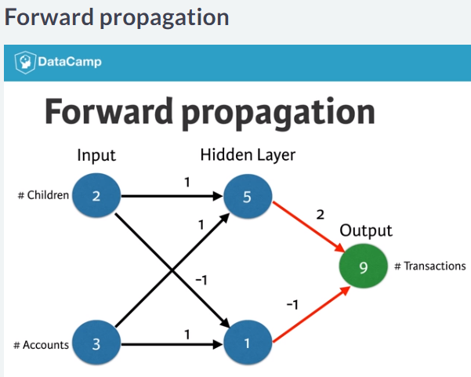

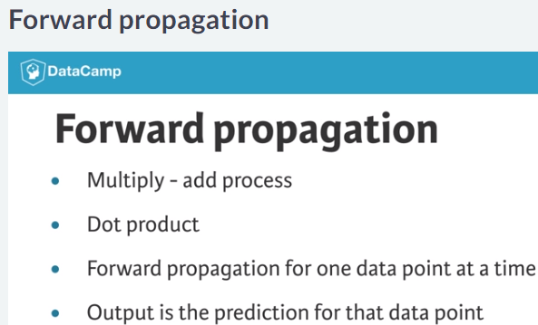

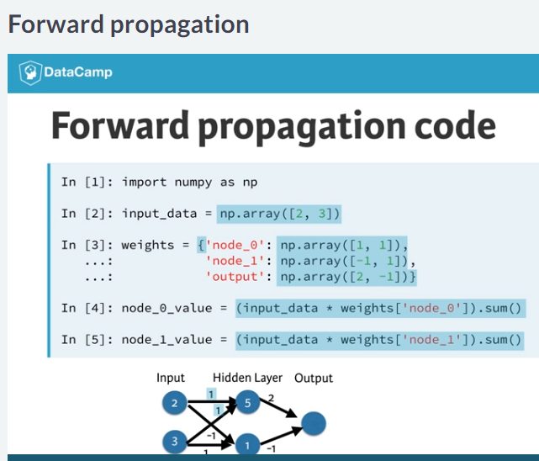

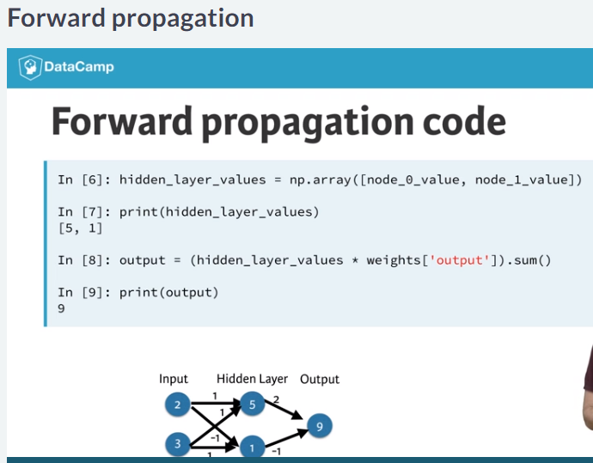

# Coding the forward propagation algorithm

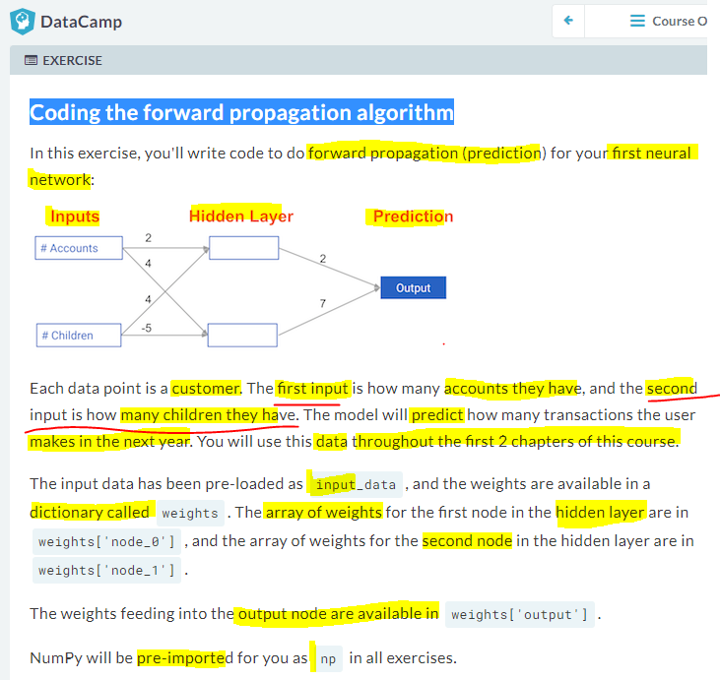

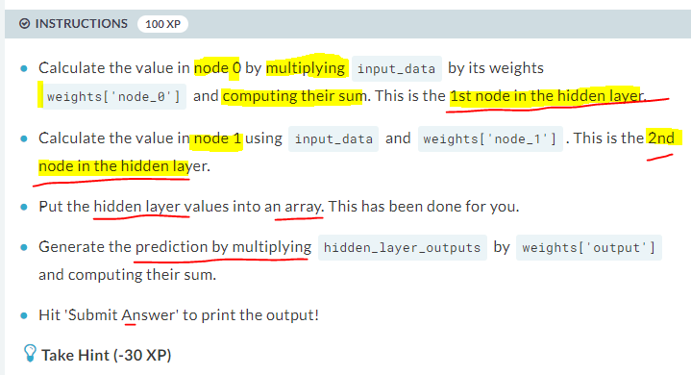

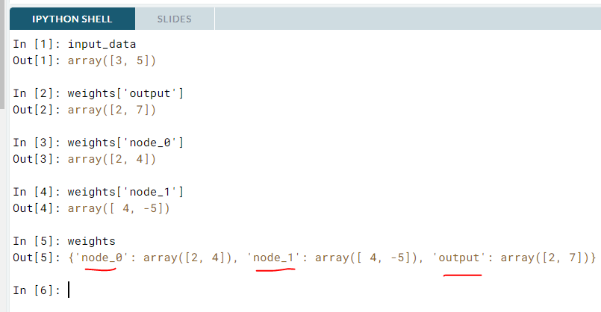

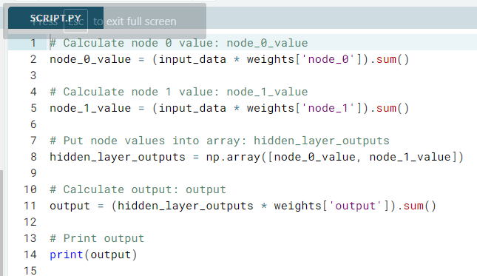

# Calculate node 0 value: node_0_value

node_0_value = (input_data * weights['node_0']).sum()

# Calculate node 1 value: node_1_value

node_1_value = (input_data * weights['node_1']).sum()

# Put node values into array: hidden_layer_outputs

hidden_layer_outputs = np.array([node_0_value, node_1_value])

# Calculate output: output

output = (hidden_layer_outputs * weights['output']).sum()

# Print output

print(output)

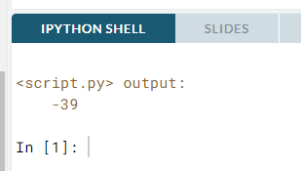

# Activation functions

If the relationship in the data aren’t straight line relationship, we will need a activation function that captures non linearity’s.

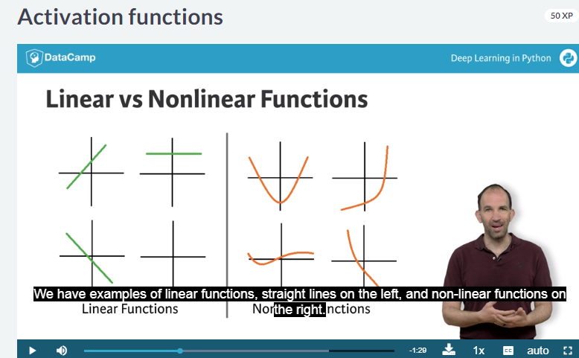

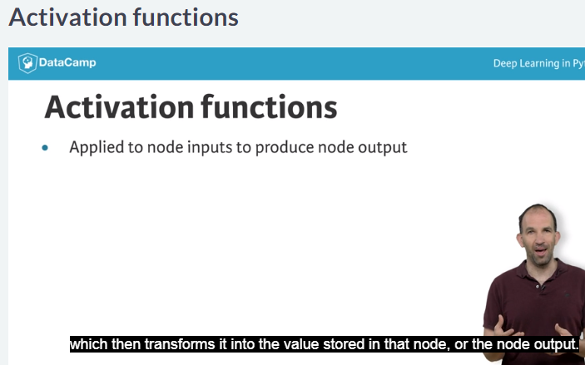

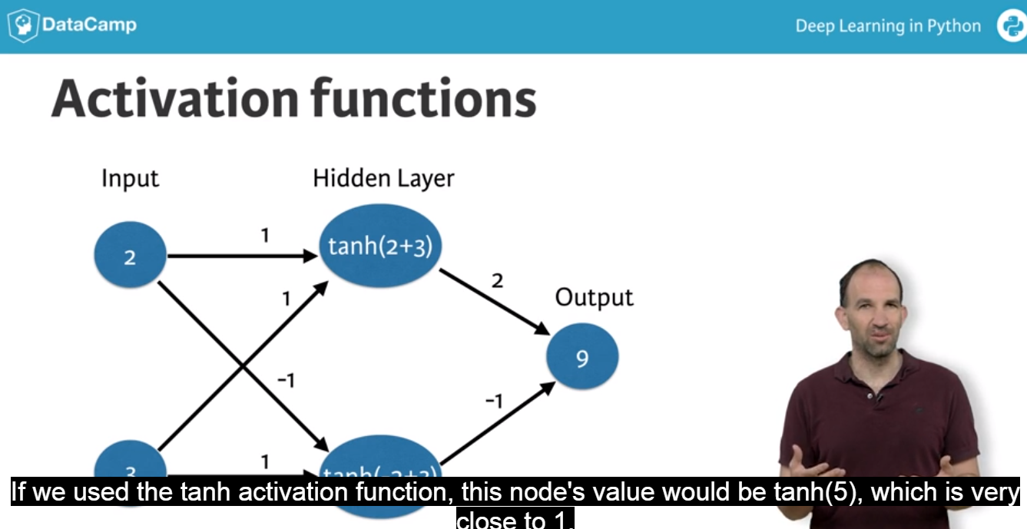

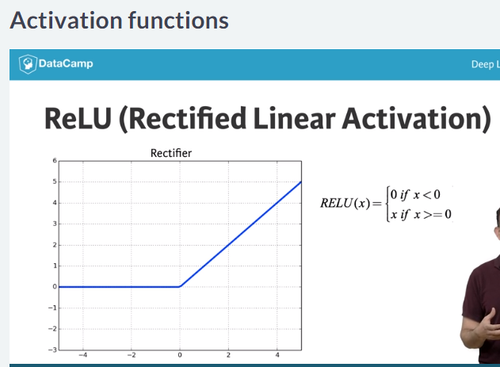

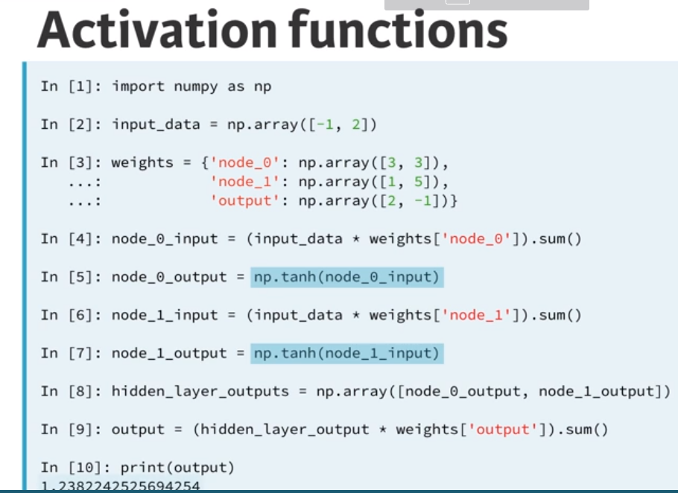

# The Rectified Linear Activation Function

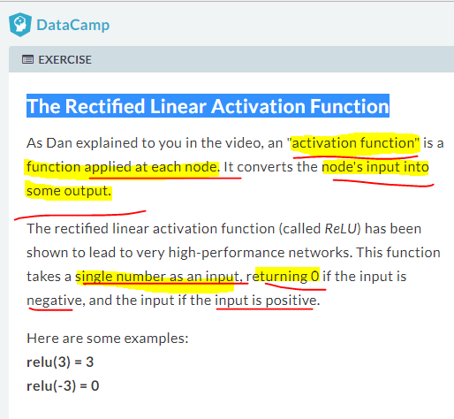

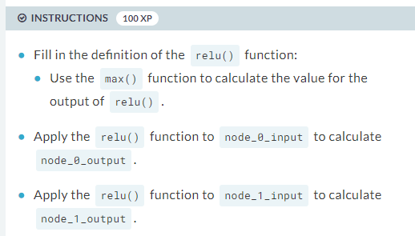

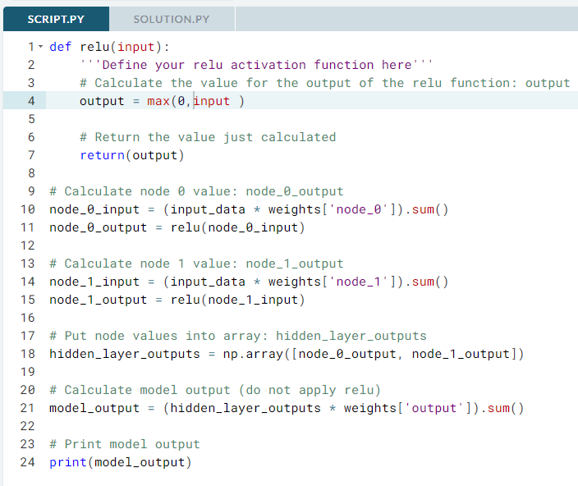

def relu(input):

'''Define your relu activation function here'''

# Calculate the value for the output of the relu function: output

output = max(0,input )

# Return the value just calculated

return(output)

# Calculate node 0 value: node_0_output

node_0_input = (input_data * weights['node_0']).sum()

node_0_output = relu(node_0_input)

# Calculate node 1 value: node_1_output

node_1_input = (input_data * weights['node_1']).sum()

node_1_output = relu(node_1_input)

# Put node values into array: hidden_layer_outputs

hidden_layer_outputs = np.array([node_0_output, node_1_output])

# Calculate model output (do not apply relu)

model_output = (hidden_layer_outputs * weights['output']).sum()

# Print model output

print(model_output)

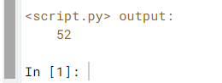

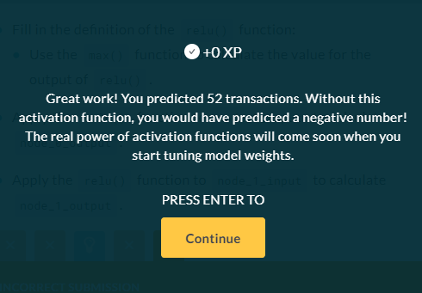

# Applying the network to many observations/rows of data

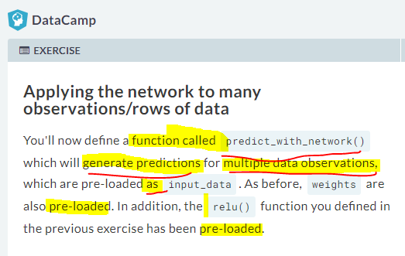

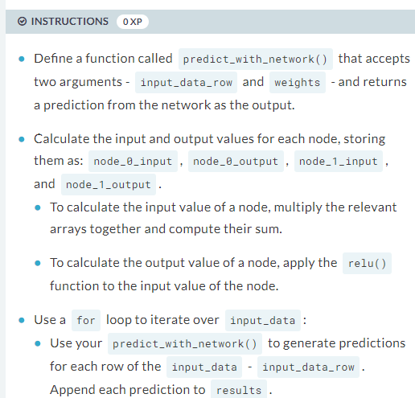

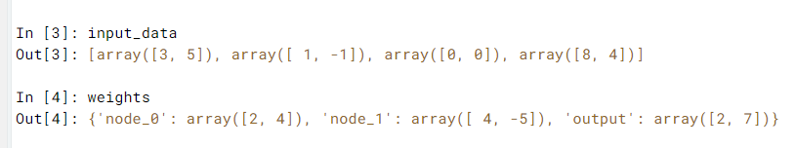

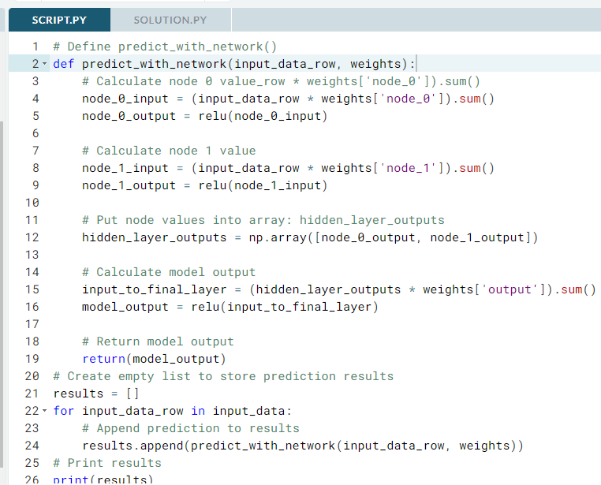

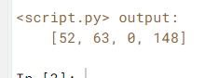

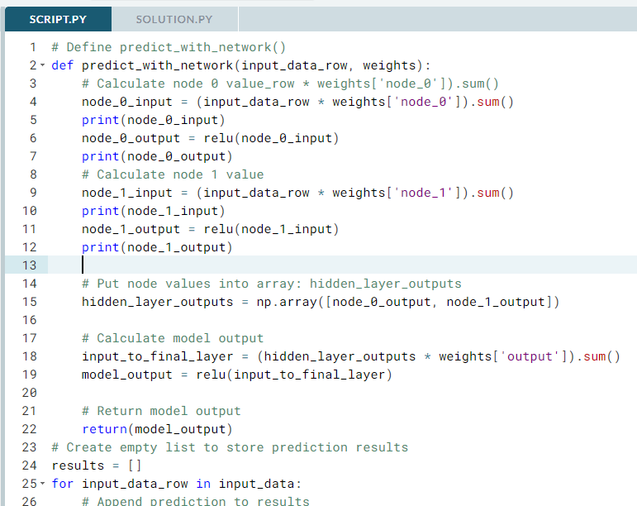

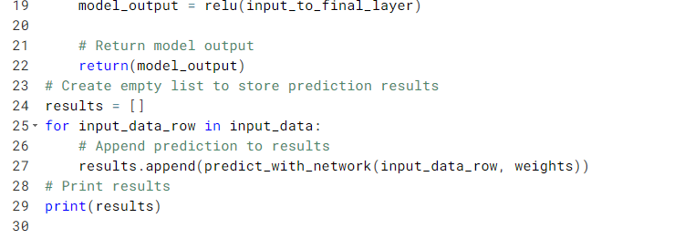

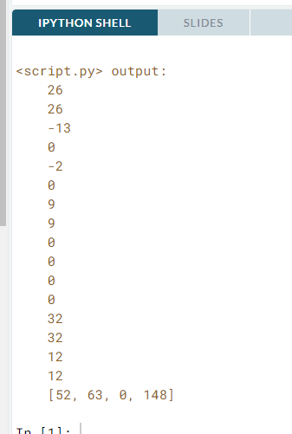

# Deeper networks

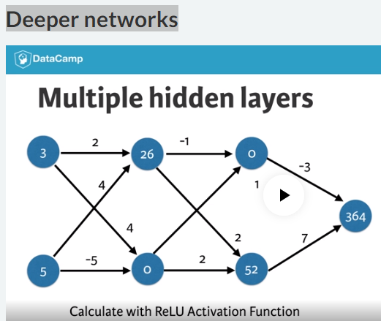

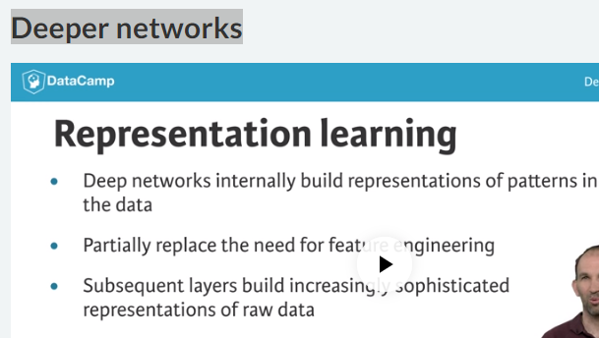

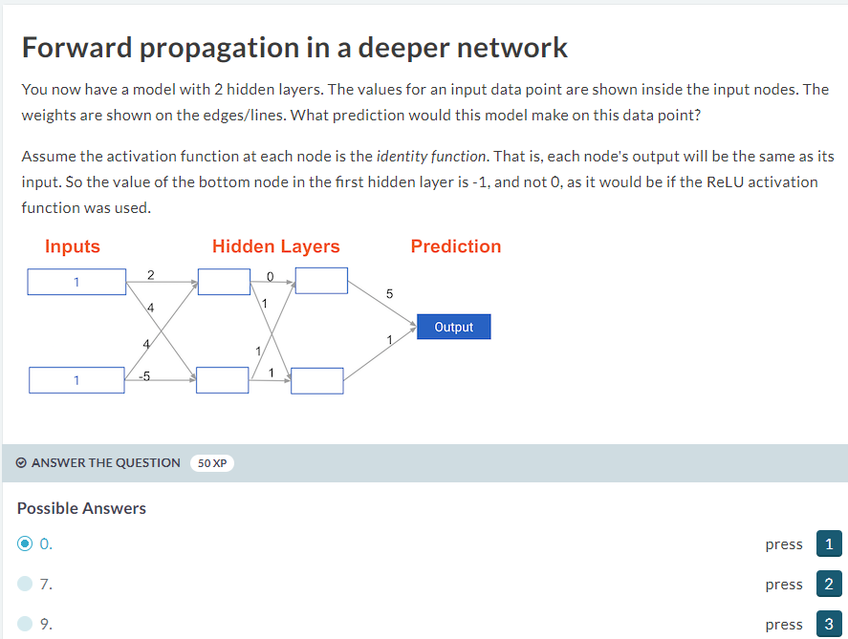

# Multi-layer neural networks

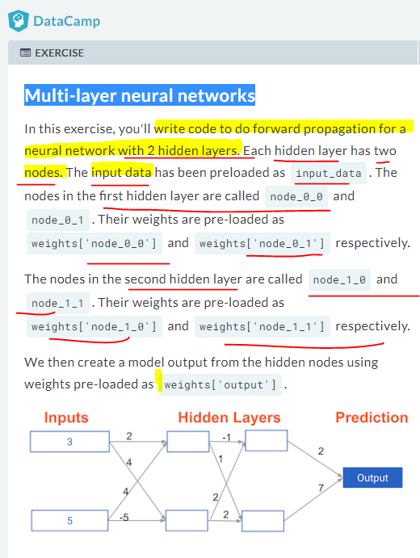

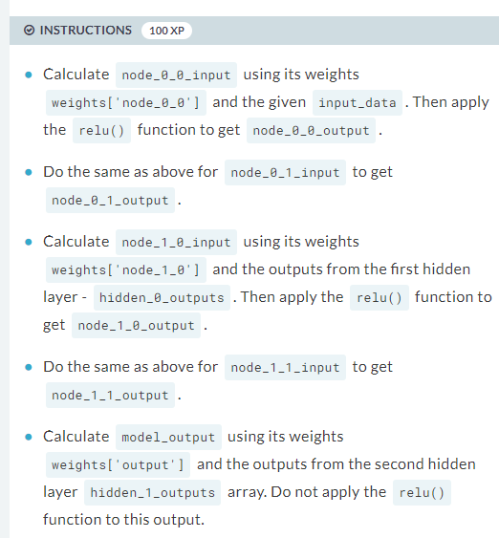

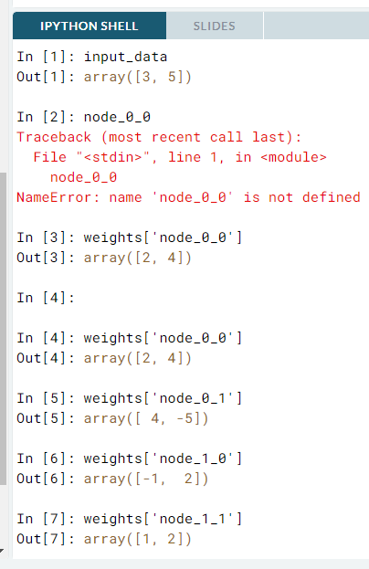

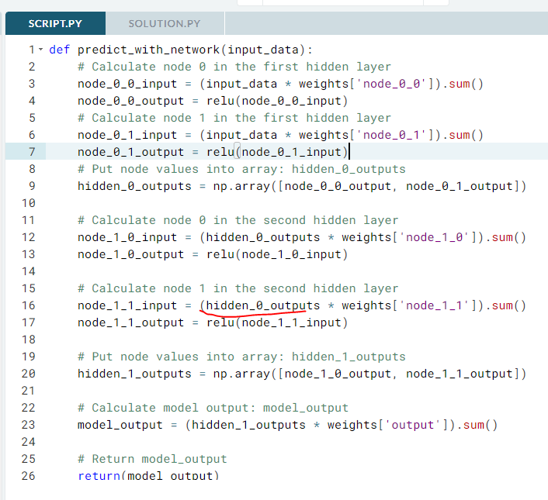

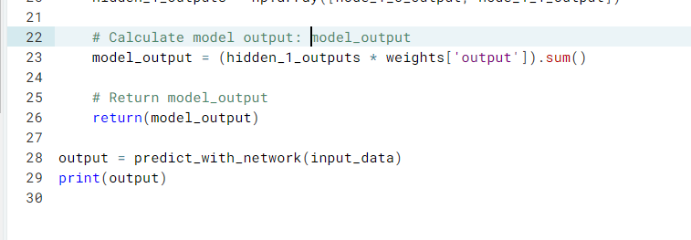

def predict_with_network(input_data):

# Calculate node 0 in the first hidden layer

node_0_0_input = (input_data * weights['node_0_0']).sum()

node_0_0_output = relu(node_0_0_input)

# Calculate node 1 in the first hidden layer

node_0_1_input = (input_data * weights['node_0_1']).sum()

node_0_1_output = relu(node_0_1_input)

# Put node values into array: hidden_0_outputs

hidden_0_outputs = np.array([node_0_0_output, node_0_1_output])

# Calculate node 0 in the second hidden layer

node_1_0_input = (hidden_0_outputs * weights['node_1_0']).sum()

node_1_0_output = relu(node_1_0_input)

# Calculate node 1 in the second hidden layer

node_1_1_input = (hidden_0_outputs * weights['node_1_1']).sum()

node_1_1_output = relu(node_1_1_input)

# Put node values into array: hidden_1_outputs

hidden_1_outputs = np.array([node_1_0_output, node_1_1_output])

# Calculate model output: model_output

model_output = (hidden_1_outputs * weights['output']).sum()

# Return model_output

return(model_output)

output = predict_with_network(input_data)

print(output)

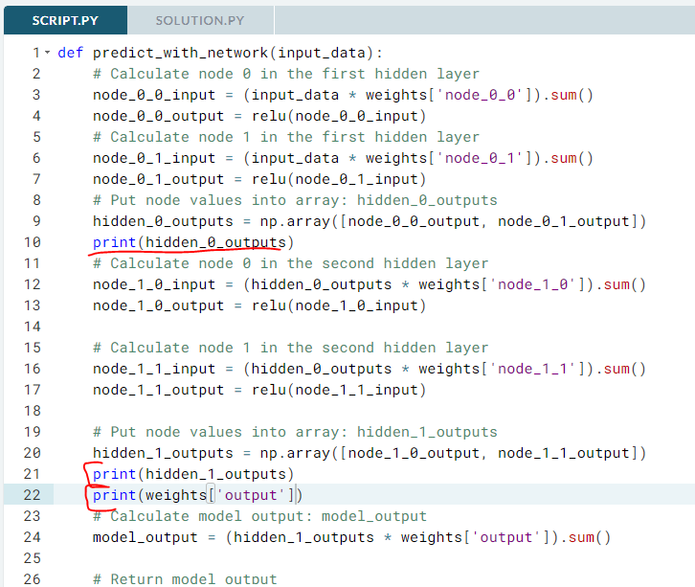

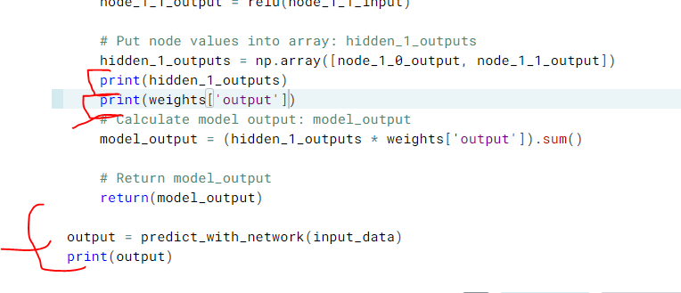

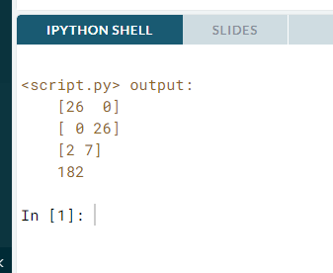

. 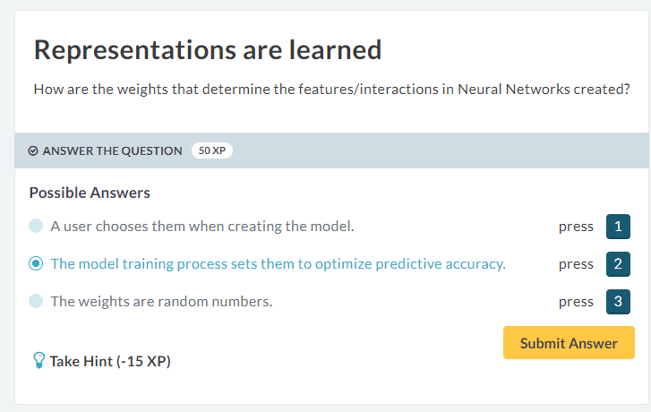



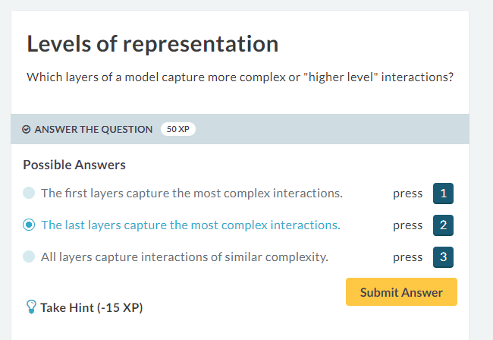



#### Optimizing a neural network with backward propagation

# The need for optimization

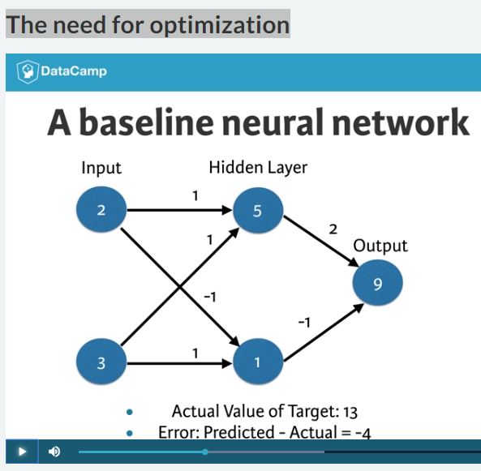

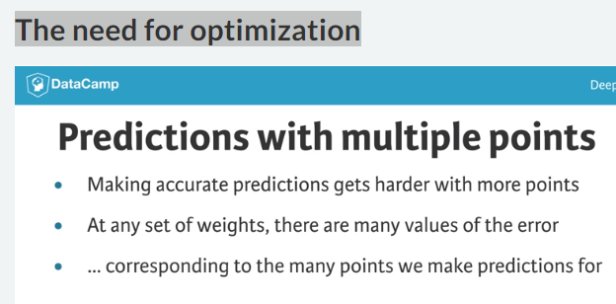

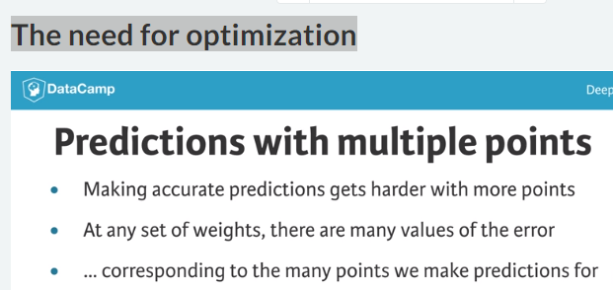

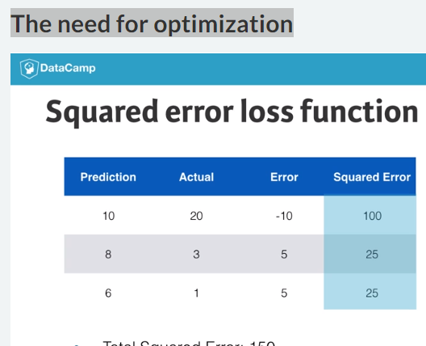

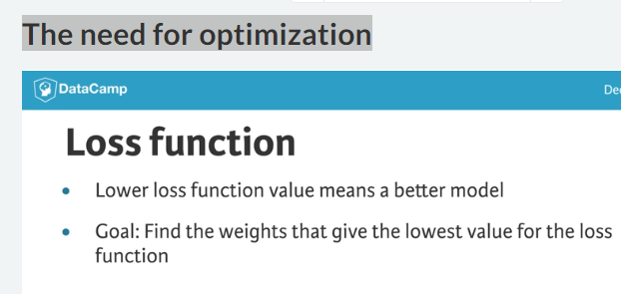

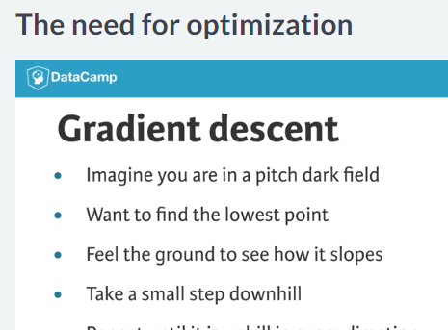

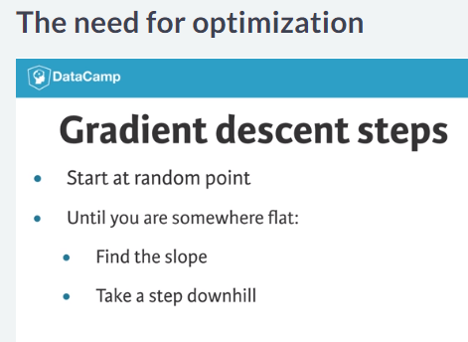

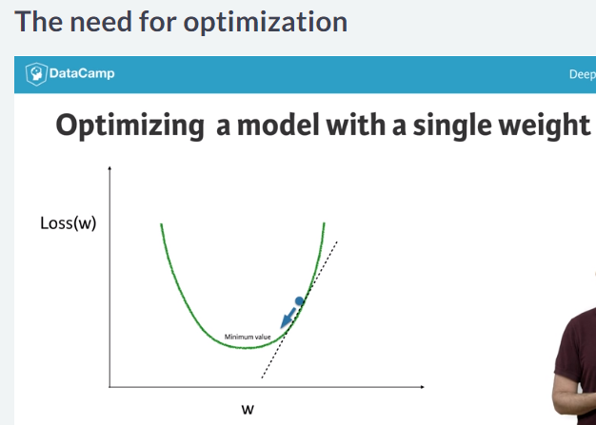

# Calculating model errors

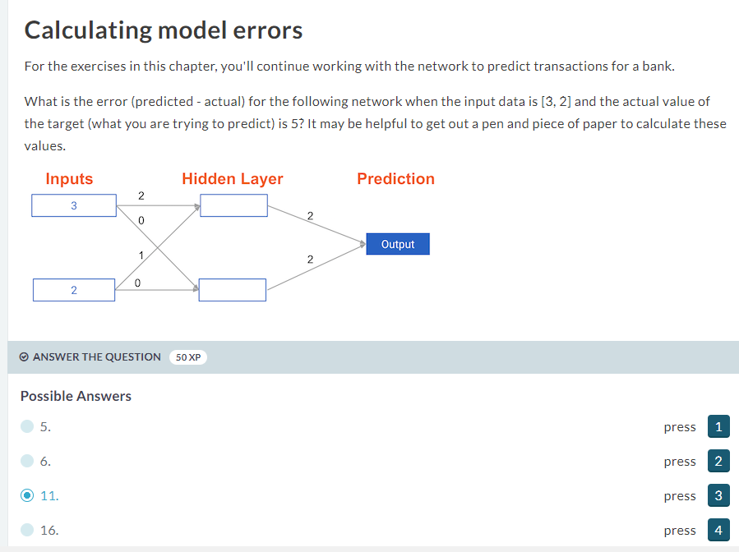



# Understanding how weights change model accuracy

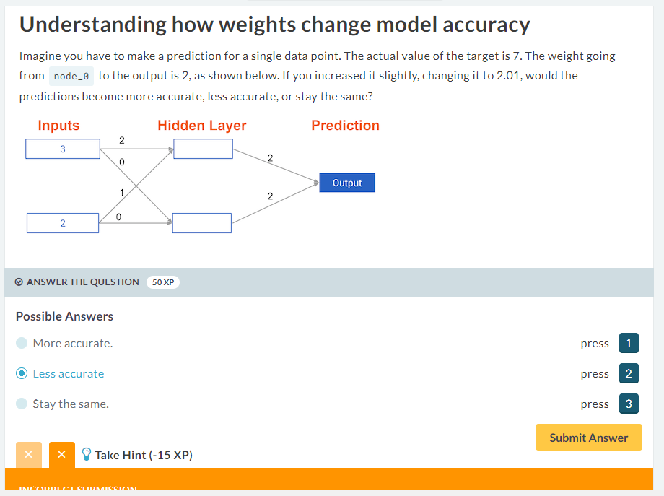

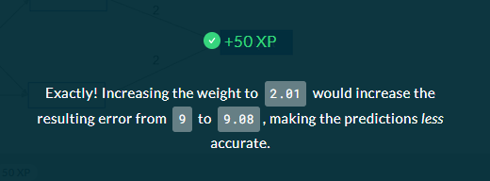

# Coding how weight changes affect accuracy

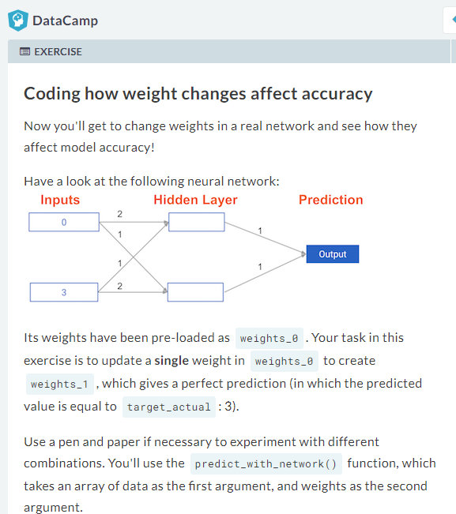

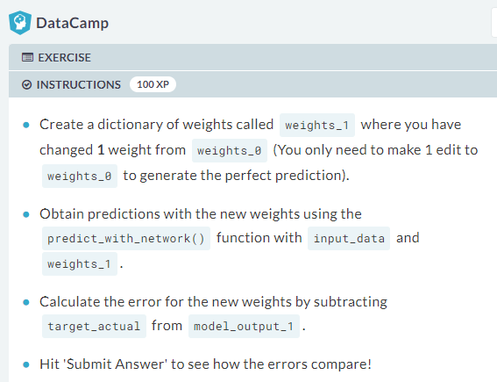

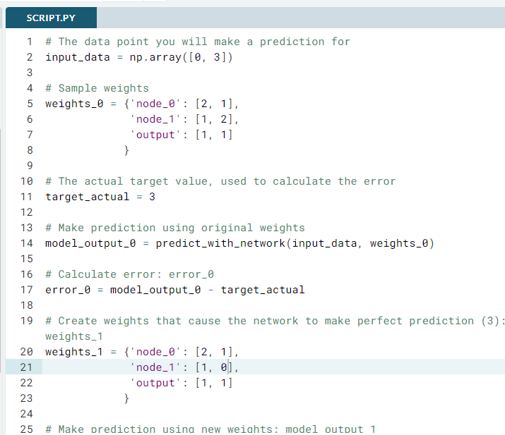

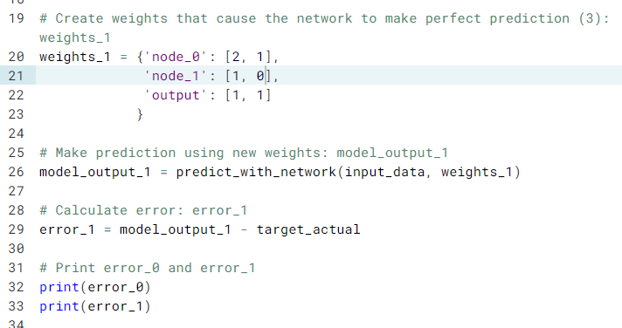

# The data point you will make a prediction for

input_data = np.array([0, 3])

# Sample weights

weights_0 = {'node_0': [2, 1],

'node_1': [1, 2],

'output': [1, 1]

}

# The actual target value, used to calculate the error

target_actual = 3

# Make prediction using original weights

model_output_0 = predict_with_network(input_data, weights_0)

# Calculate error: error_0

error_0 = model_output_0 - target_actual

# Create weights that cause the network to make perfect prediction (3): weights_1

weights_1 = {'node_0': [2, 1],

'node_1': [1, 0],

'output': [1, 1]

}

# Make prediction using new weights: model_output_1

model_output_1 = predict_with_network(input_data, weights_1)

# Calculate error: error_1

error_1 = model_output_1 - target_actual

# Print error_0 and error_1

print(error_0)

print(error_1)

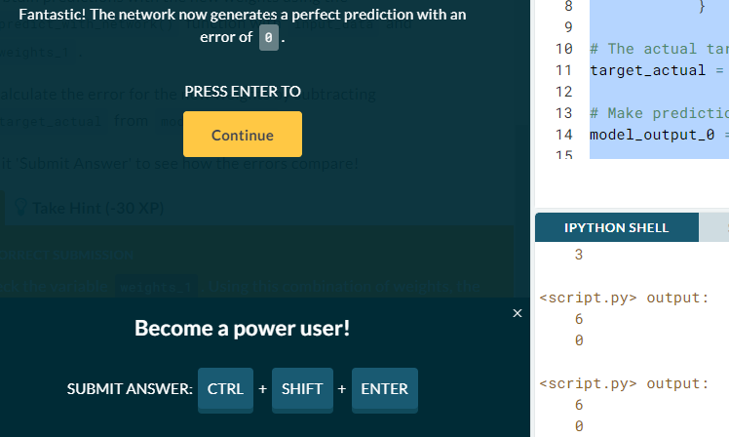

# Scaling up to multiple data points

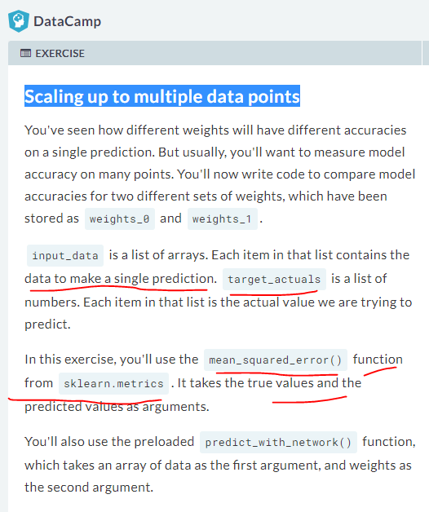

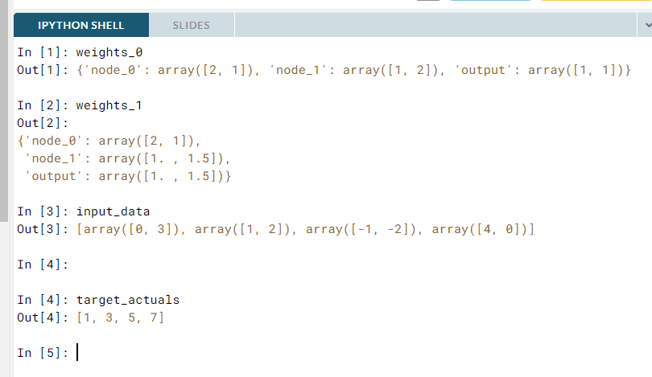

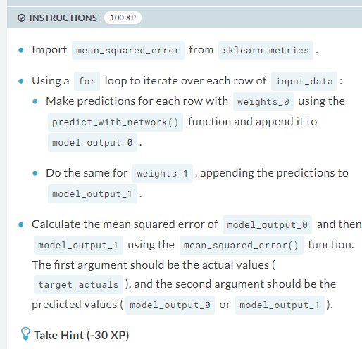

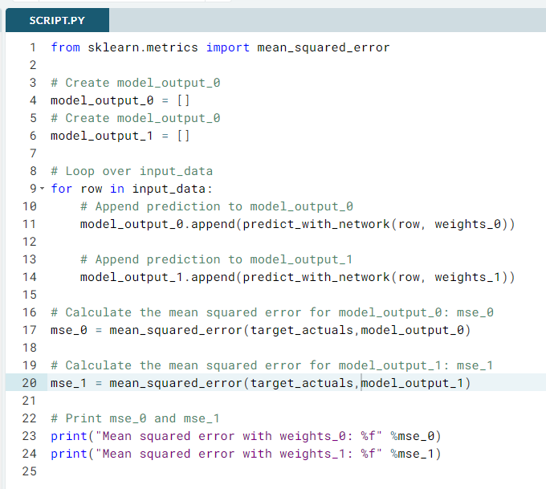

from sklearn.metrics import mean_squared_error

# Create model_output_0

model_output_0 = []

# Create model_output_0

model_output_1 = []

# Loop over input_data

for row in input_data:

# Append prediction to model_output_0

model_output_0.append(predict_with_network(row, weights_0))

# Append prediction to model_output_1

model_output_1.append(predict_with_network(row, weights_1))

# Calculate the mean squared error for model_output_0: mse_0

mse_0 = mean_squared_error(target_actuals,model_output_0)

# Calculate the mean squared error for model_output_1: mse_1

mse_1 = mean_squared_error(target_actuals,model_output_1)

# Print mse_0 and mse_1

print("Mean squared error with weights_0: %f" %mse_0)

print("Mean squared error with weights_1: %f" %mse_1)



# Gradient descent

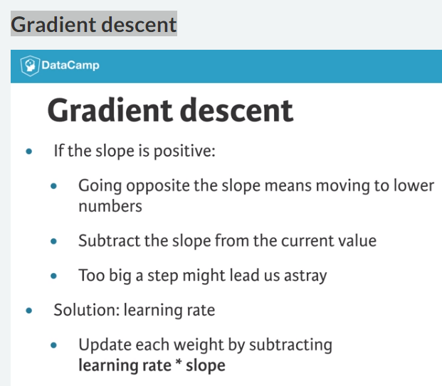

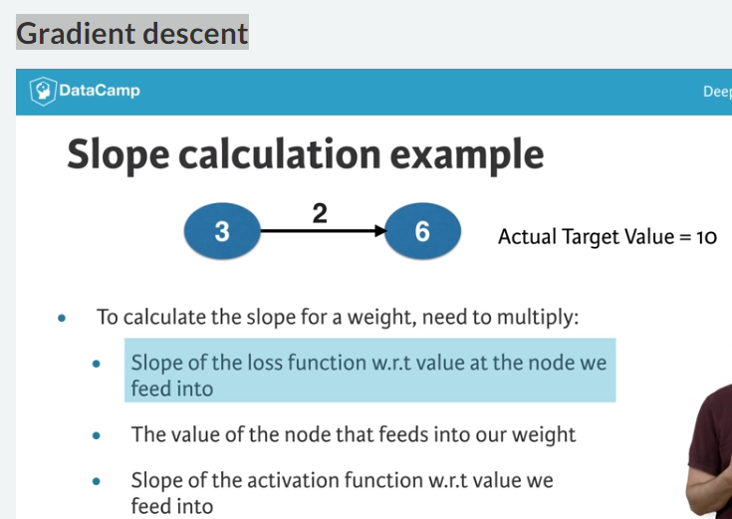



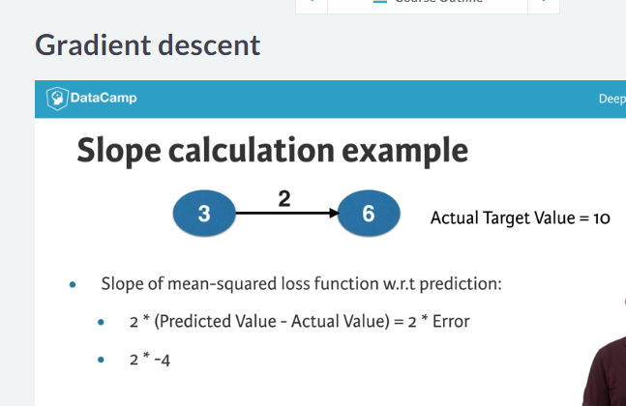

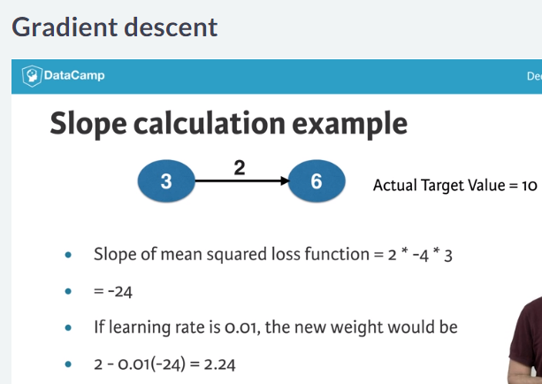

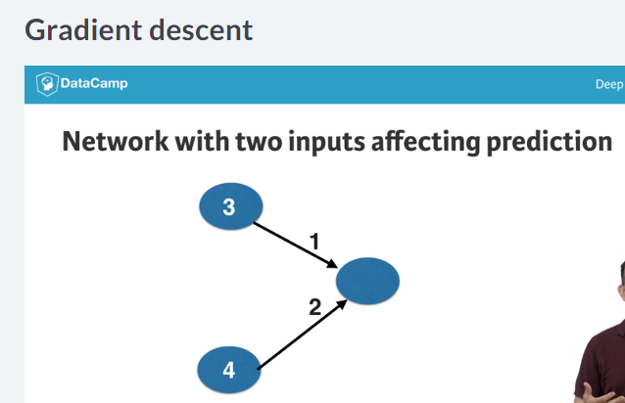

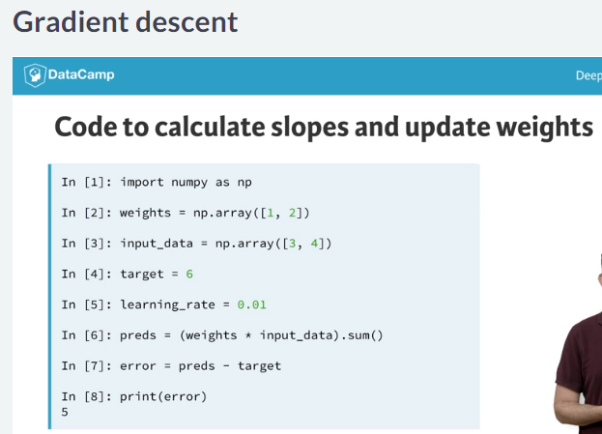

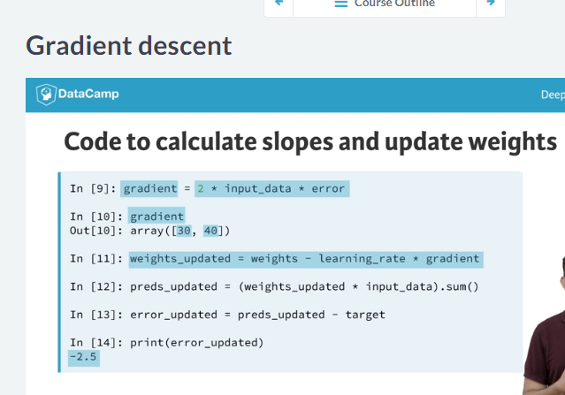

# Calculating slopes

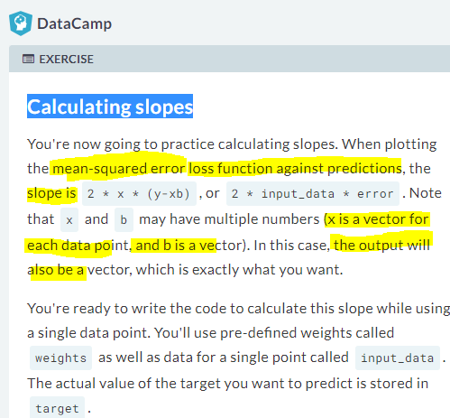

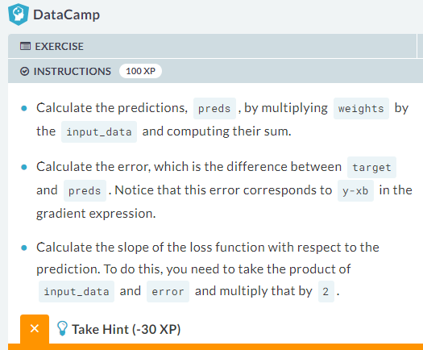

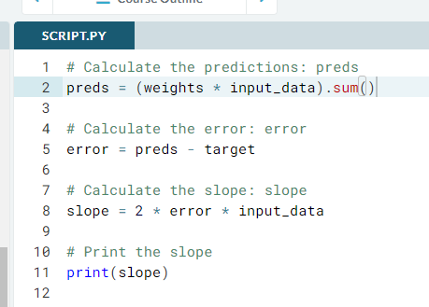

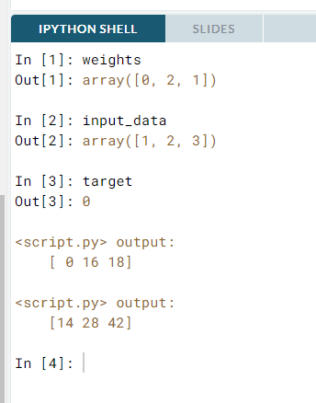



# Improving model weights

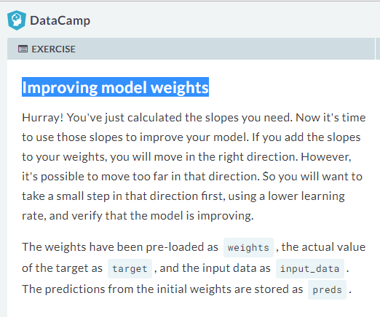

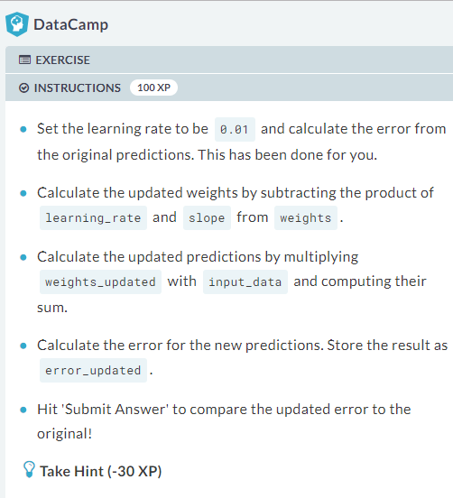

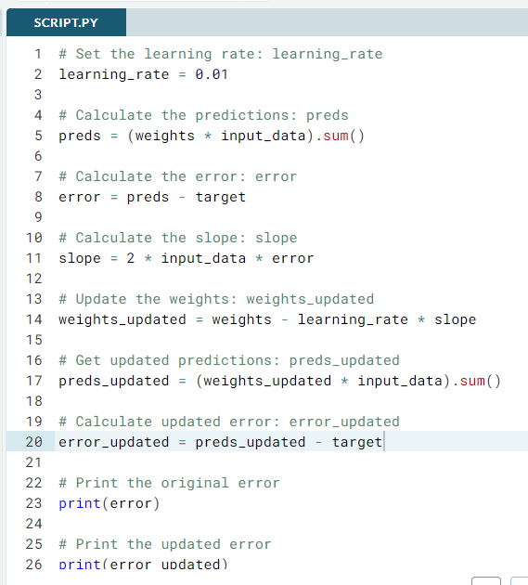

# Set the learning rate: learning_rate

learning_rate = 0.01

# Calculate the predictions: preds

preds = (weights * input_data).sum()

# Calculate the error: error

error = preds - target

# Calculate the slope: slope

slope = 2 * input_data * error

# Update the weights: weights_updated

weights_updated = weights - learning_rate * slope

# Get updated predictions: preds_updated

preds_updated = (weights_updated * input_data).sum()

# Calculate updated error: error_updated

error_updated = preds_updated - target

# Print the original error

print(error)

# Print the updated error

print(error_updated)

# Making multiple updates to weights

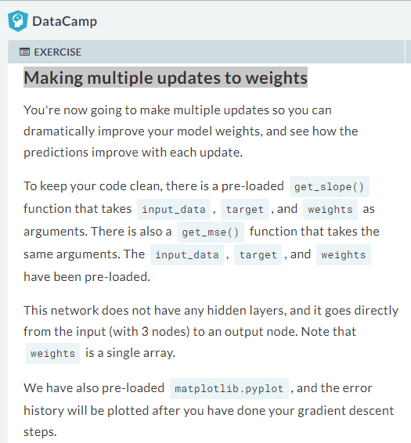

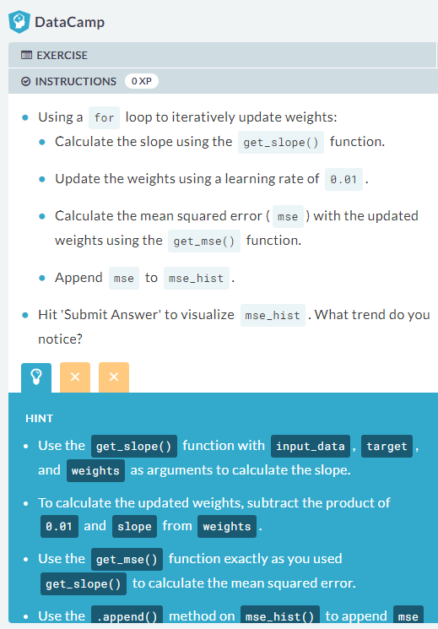

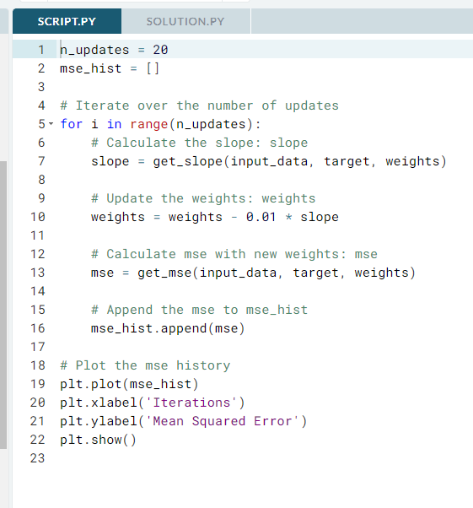

n_updates = 20

mse_hist = []

# Iterate over the number of updates

for i in range(n_updates):

# Calculate the slope: slope

slope = get_slope(input_data, target, weights)

# Update the weights: weights

weights = weights - 0.01 * slope

# Calculate mse with new weights: mse

mse = get_mse(input_data, target, weights)

# Append the mse to mse_hist

mse_hist.append(mse)

# Plot the mse history

plt.plot(mse_hist)

plt.xlabel('Iterations')

plt.ylabel('Mean Squared Error')

plt.show()

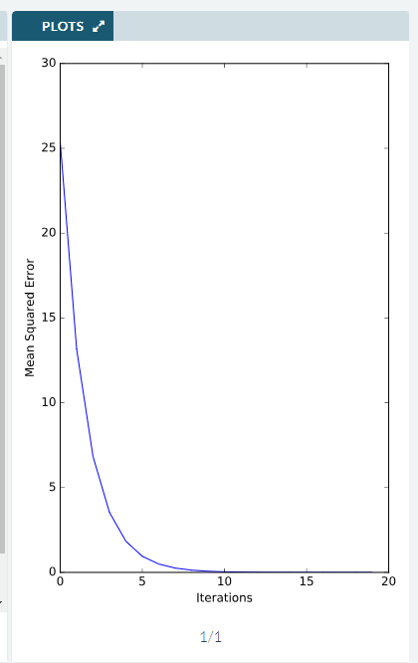



# Back propagation

1. Back propagation to calculate the slope we need to optimize more complex deep learning models.
2. Just as forward propagation sends input data through hidden layers and into the output layer.
3. Back propagation takes the error from the output layer and propagates it back ward through the hidden layers, towards the input layer

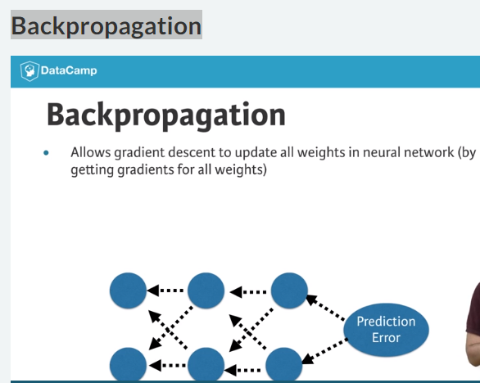

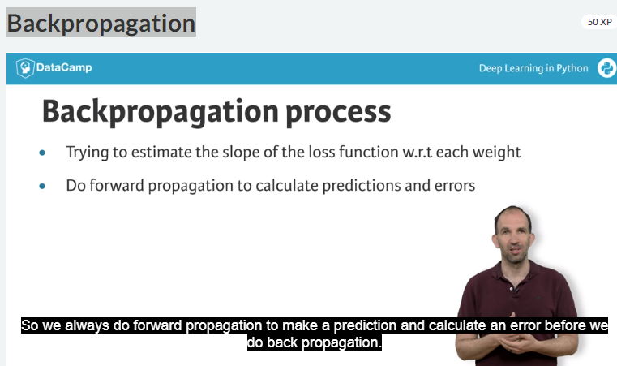

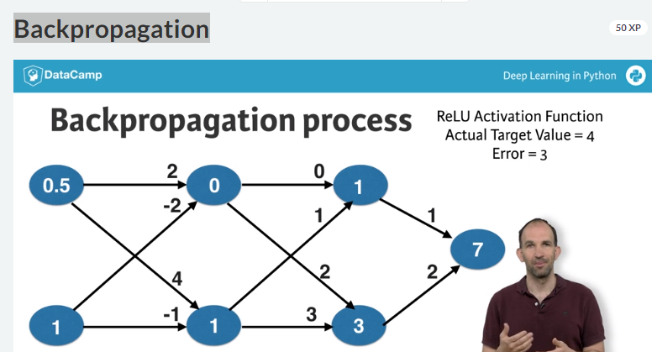

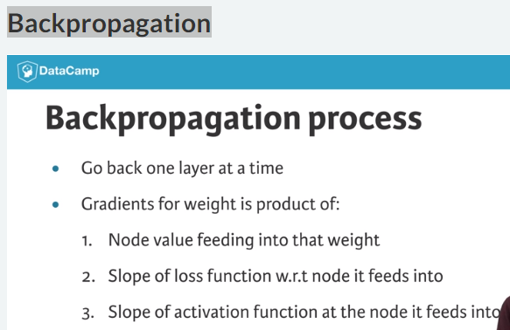

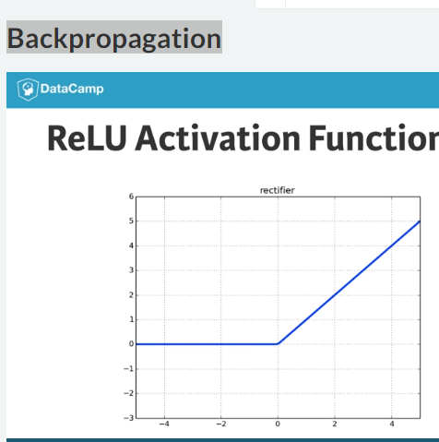

# The relationship between forward and backward propagati



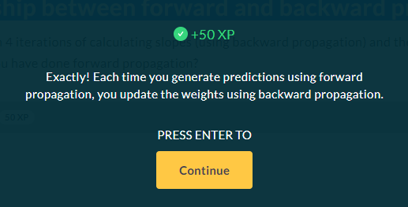

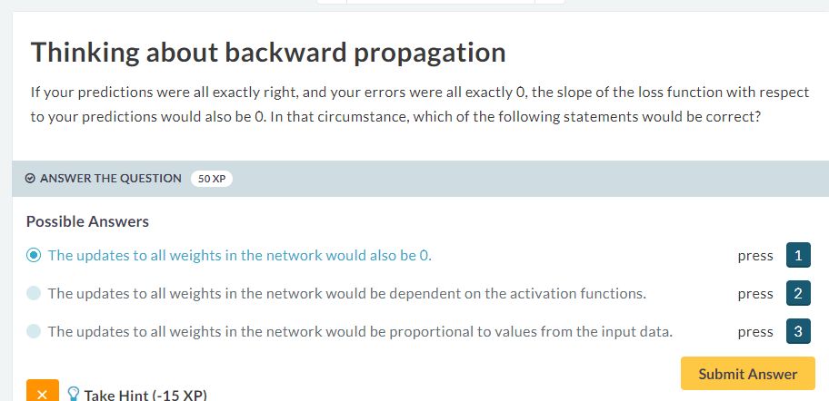



# Backpropagation in practice

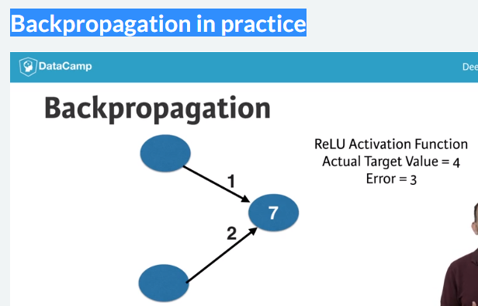

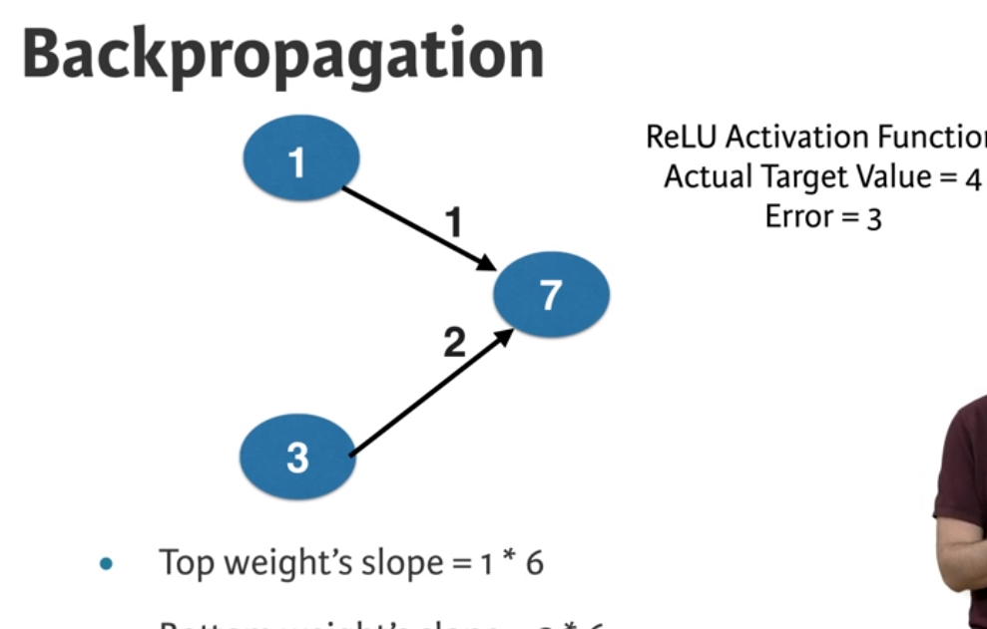

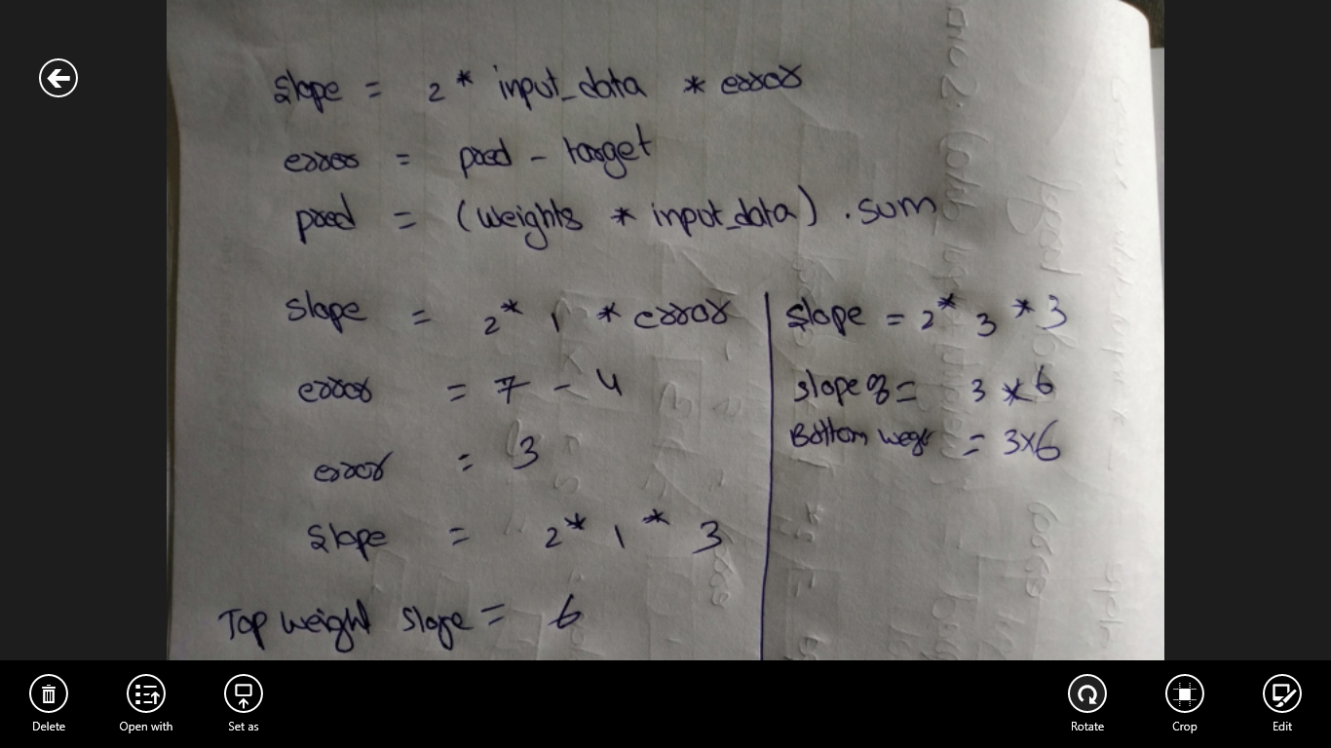

White to denote node values, black to denote weight values and the red shows the calculated slopes of the loss function with respect to the node

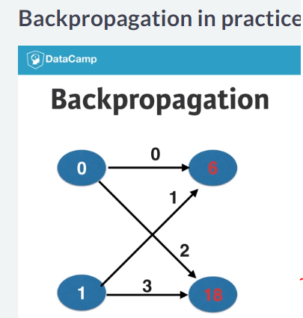

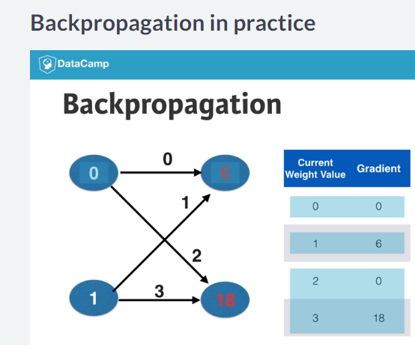

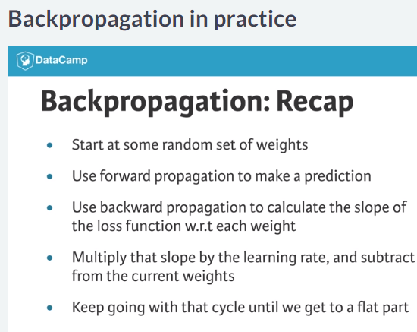

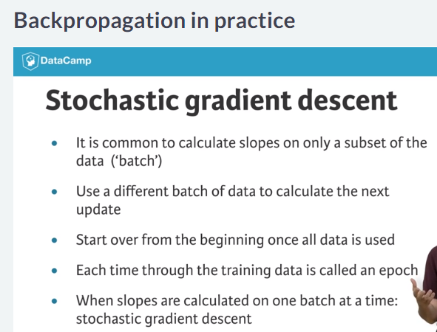

# The need for optimization

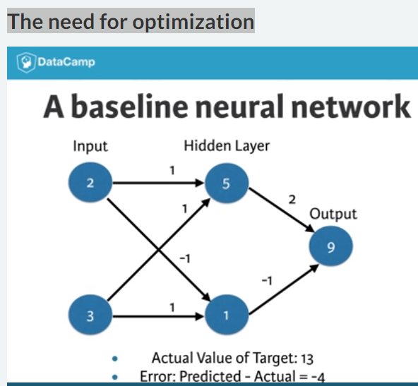

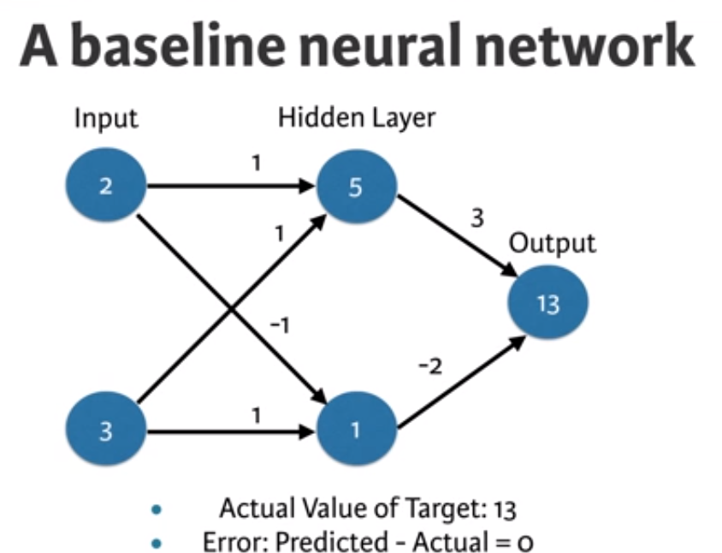

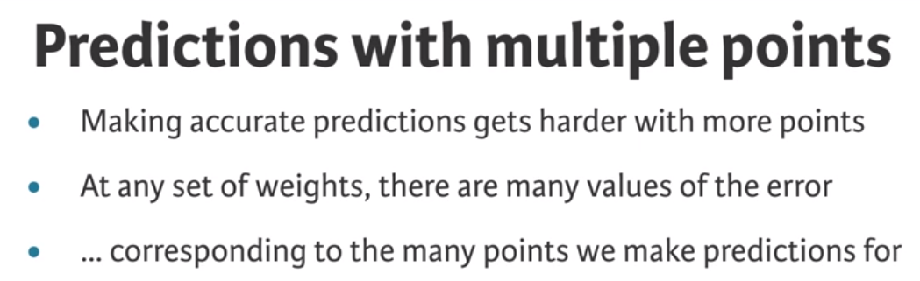

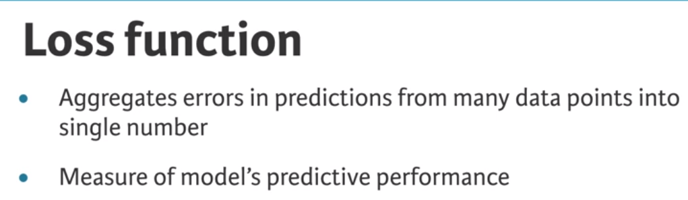

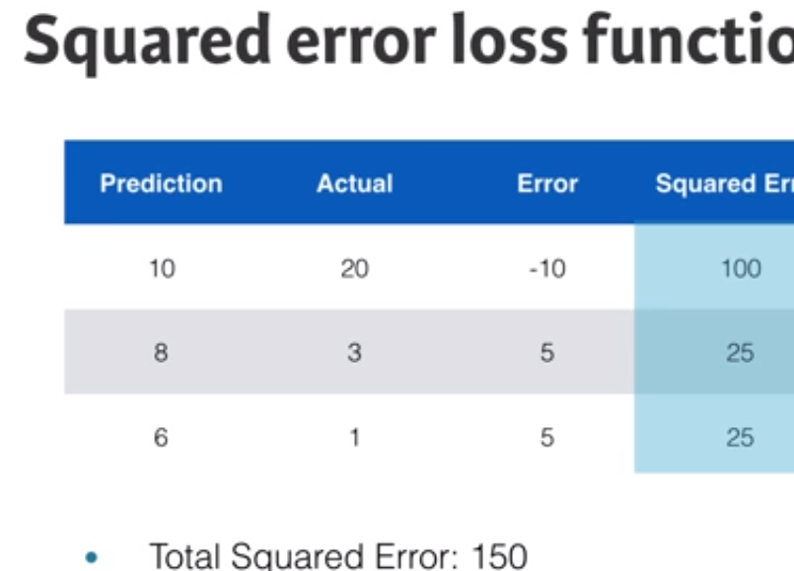

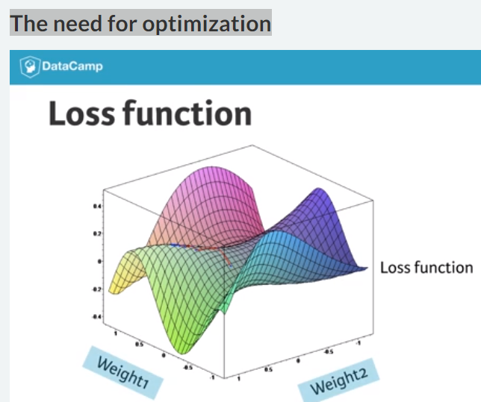

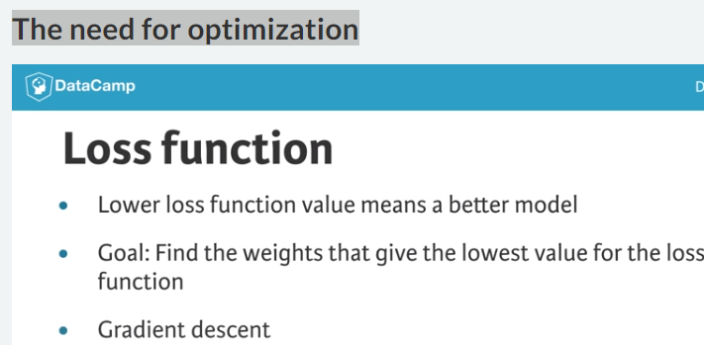

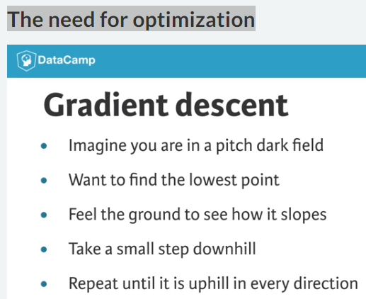

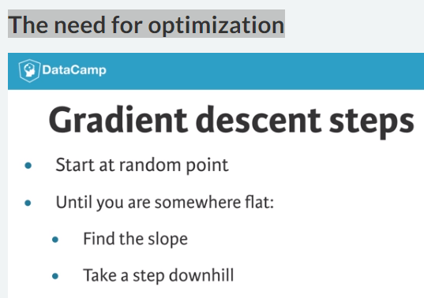

#### Building deep learning models with keras



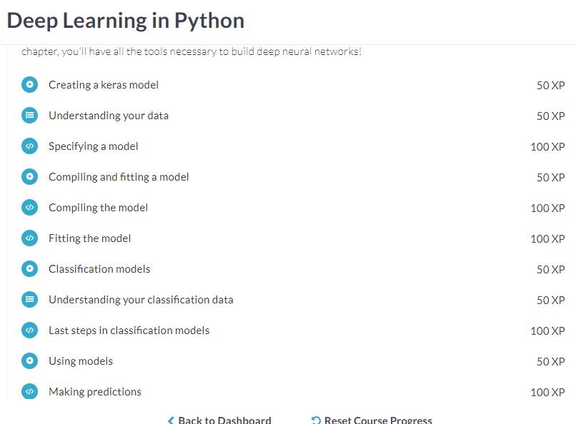

# Creating a keras model



Model specification

This code has three blocks

1. In first block, We import models numpy , keras. The other two are used for building our model.

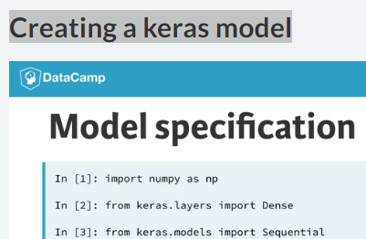

1. The second block of two lines read the data, we read the data here so we can find the number of nodes in the input layer that stored as the variable as N_cols.

Note: we always need to specify how many columns are there in input

When building keras model , because that is the number of node in the input layer.

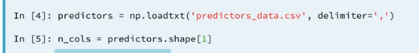

1. In third block, we start building the model
2. There are two ways to build up a model, and we focus on sequential, which is easier way to build a model.
3. In first line of model specification is model = seqquential.
4. We start adding layer using the add method of the model the standard layer type is called the Dence layer.

Note : It is called dence layer because all of the nodes in the previous layer connect to all of the nodes in the current layer.

1. Dence, in each layer we specify the **number of nodes** as the first positional arguments and the **activation function** we want use in that layer using the keyword argument activation function. In the first layer, **we need to specify input shapes.** You’ll notice the last layer has 1 node that is the output layer

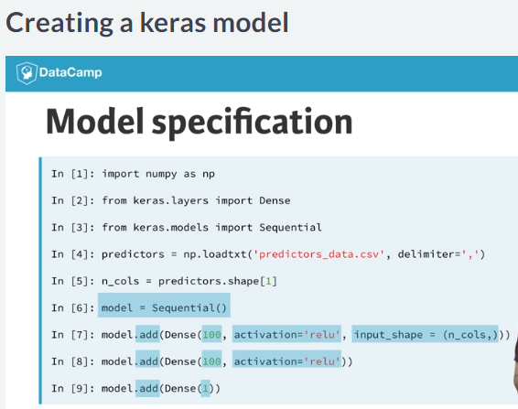

# Understanding your data

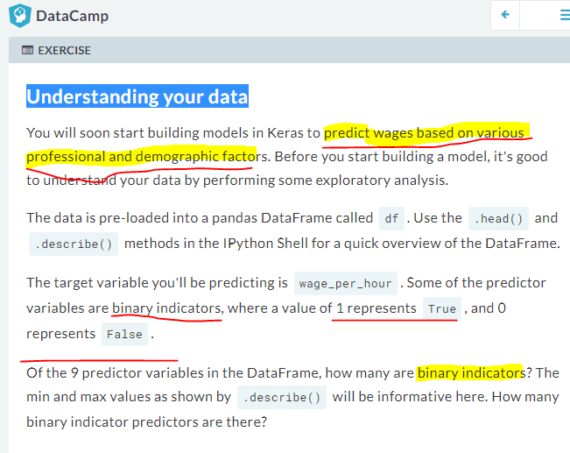

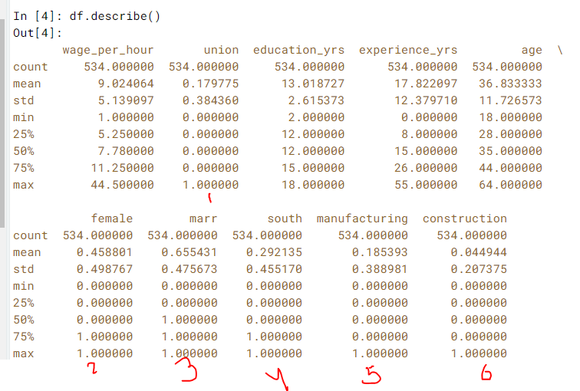



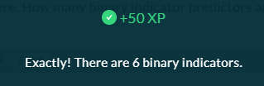

# Specifying a model

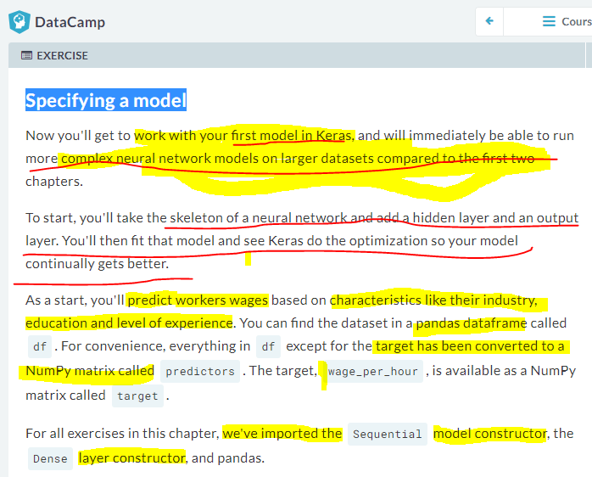

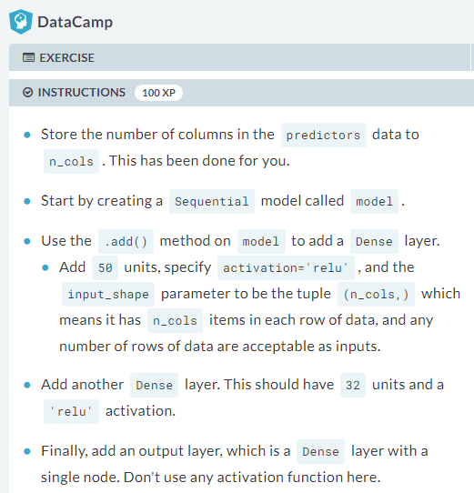

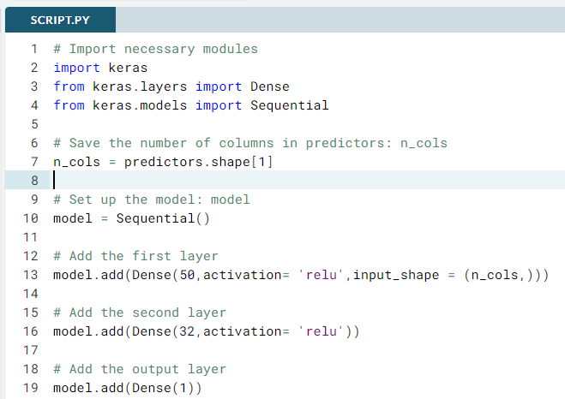

# Import necessary modules

import keras

from keras.layers import Dense

from keras.models import Sequential

# Save the number of columns in predictors: n_cols

n_cols = predictors.shape[1]

# Set up the model: model

model = Sequential()

# Add the first layer

model.add(Dense(50,activation= 'relu',input_shape = (n_cols,)))

# Add the second layer

model.add(Dense(32,activation= 'relu'))

# Add the output layer

model.add(Dense(1))



# Compiling and fitting a model

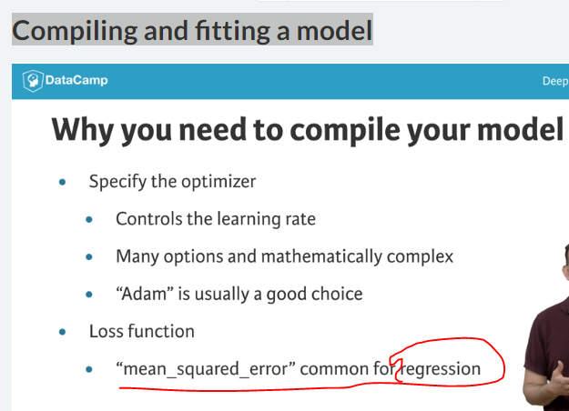

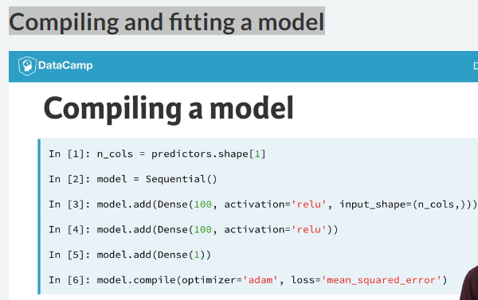

Fitting a model

Applying the back propagation and gradient descent with your data to update the weights

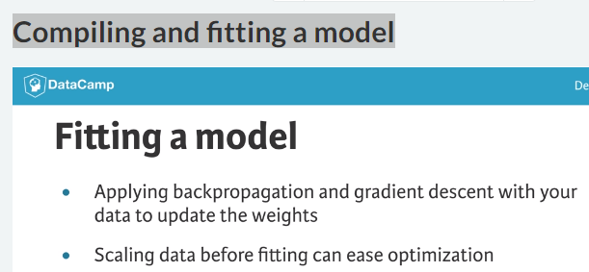

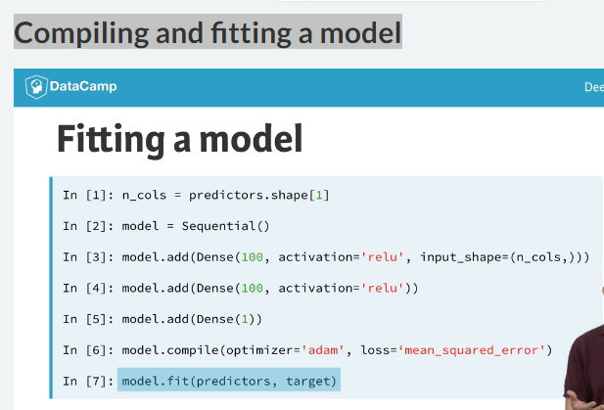

# Compiling the model

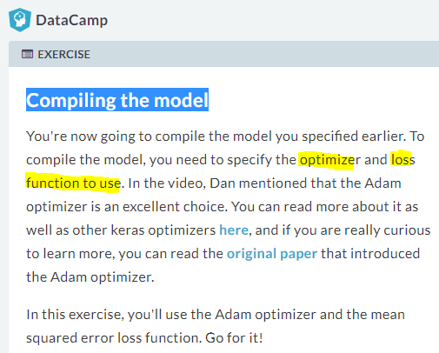

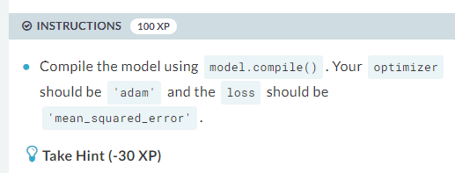

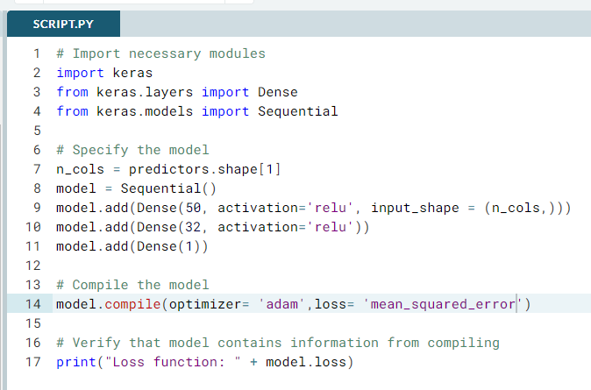

# Import necessary modules

import keras

from keras.layers import Dense

from keras.models import Sequential

# Specify the model

n_cols = predictors.shape[1]

model = Sequential()

model.add(Dense(50, activation='relu', input_shape = (n_cols,)))

model.add(Dense(32, activation='relu'))

model.add(Dense(1))

# Compile the model

model.compile(optimizer= 'adam',loss= 'mean_squared_error')

# Verify that model contains information from compiling

print("Loss function: " + model.loss)

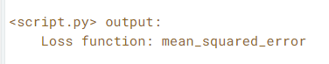

# Fitting the model

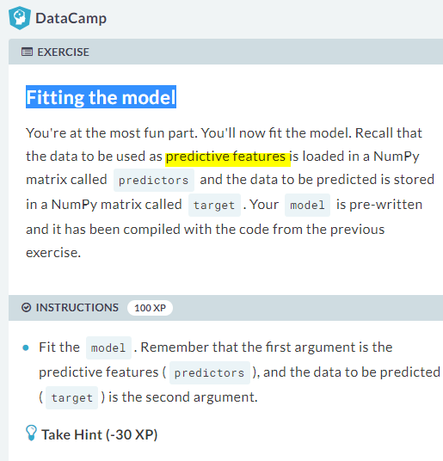

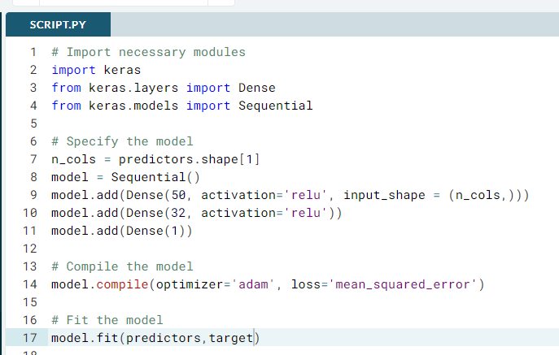

# Import necessary modules

import keras

from keras.layers import Dense

from keras.models import Sequential

# Specify the model

n_cols = predictors.shape[1]

model = Sequential()

model.add(Dense(50, activation='relu', input_shape = (n_cols,)))

model.add(Dense(32, activation='relu'))

model.add(Dense(1))

# Compile the model

model.compile(optimizer='adam', loss='mean_squared_error')

# Fit the model

model.fit(predictors,target)



# Classification models

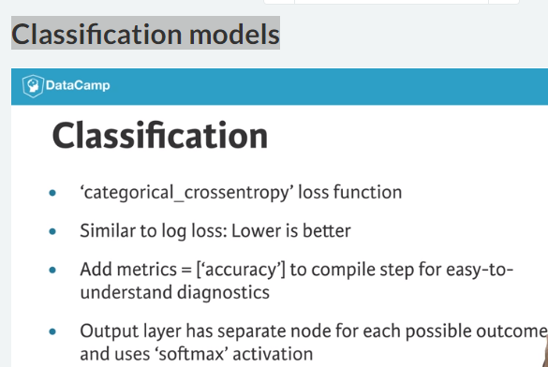

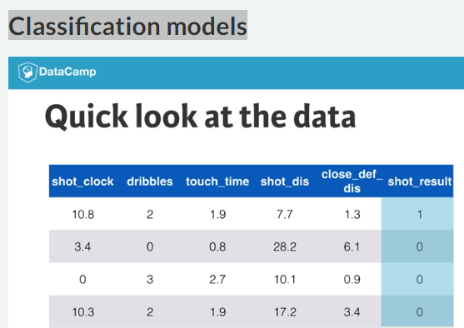

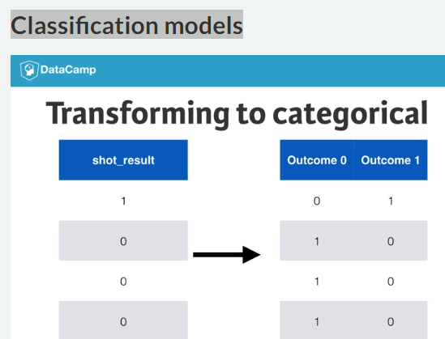

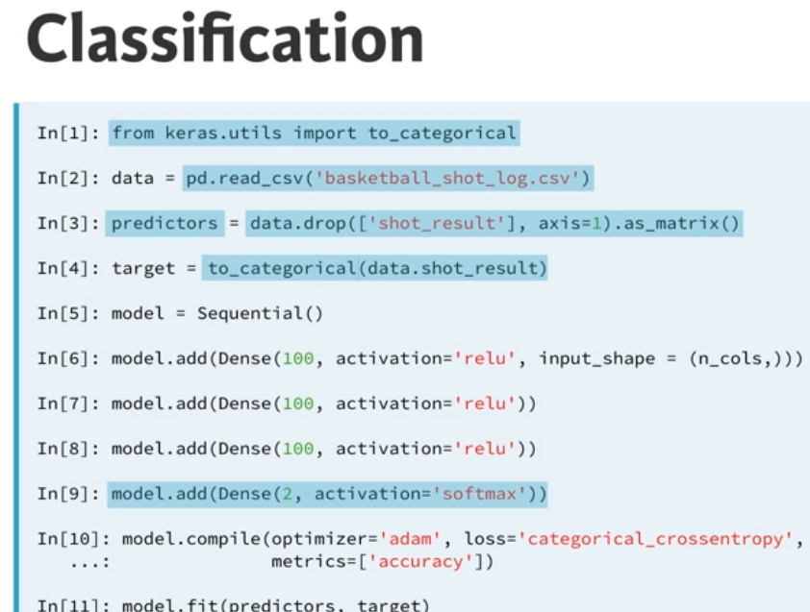

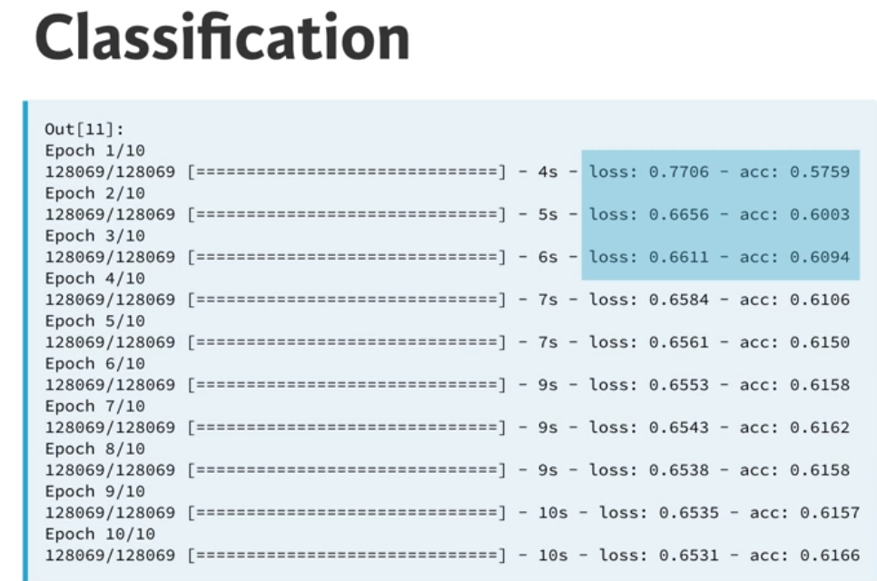



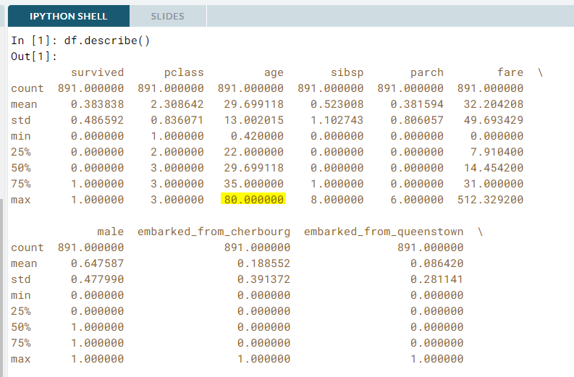

# Understanding your classification data

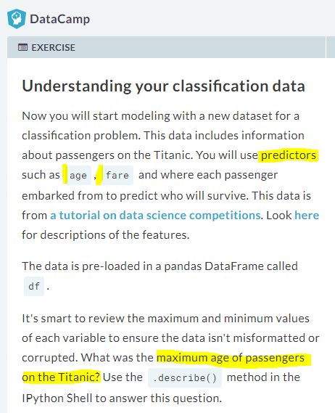

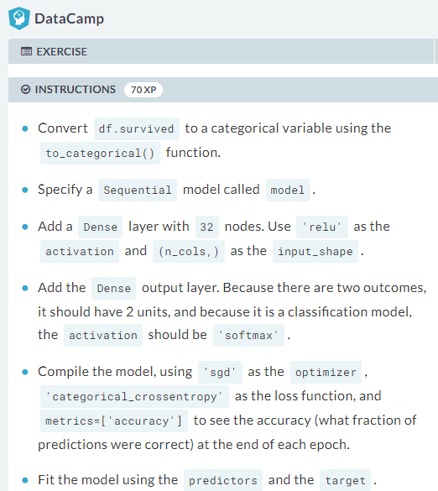

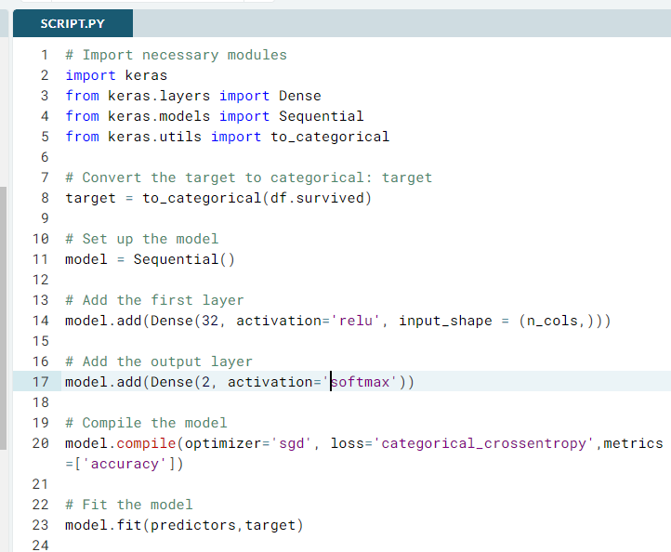

# Import necessary modules

import keras

from keras.layers import Dense

from keras.models import Sequential

from keras.utils import to_categorical

# Convert the target to categorical: target

target = to_categorical(df.survived)

# Set up the model

model = Sequential()

# Add the first layer

model.add(Dense(32, activation='relu', input_shape = (n_cols,)))

# Add the output layer

model.add(Dense(2, activation='softmax'))

# Compile the model

model.compile(optimizer='sgd', loss='categorical_crossentropy',metrics=['accuracy'])

# Fit the model

model.fit(predictors,target)

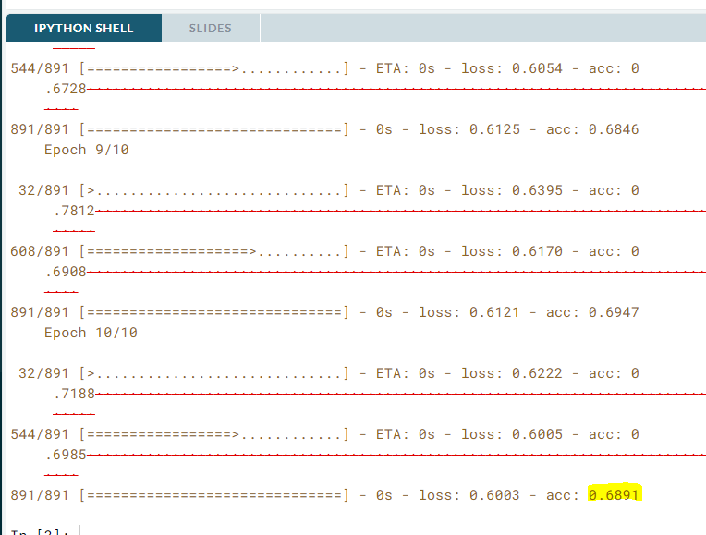



# Using models

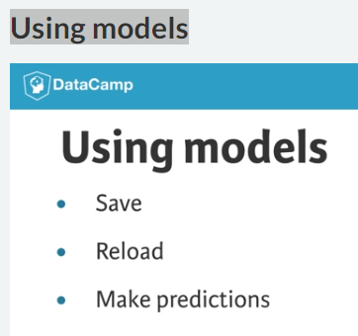

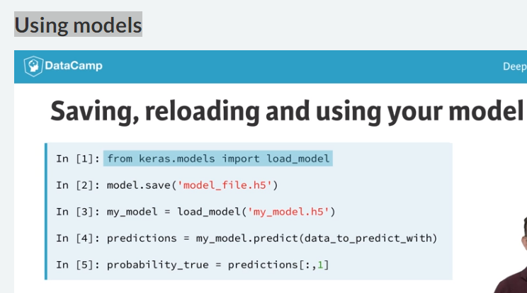

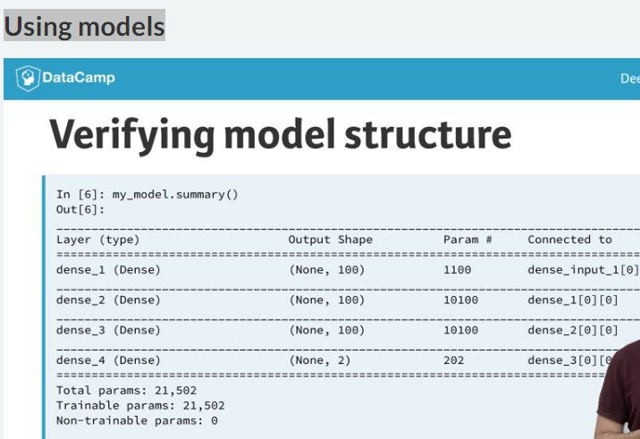

# Making predictions

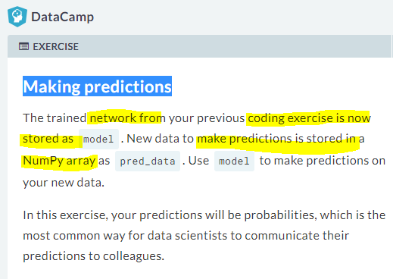

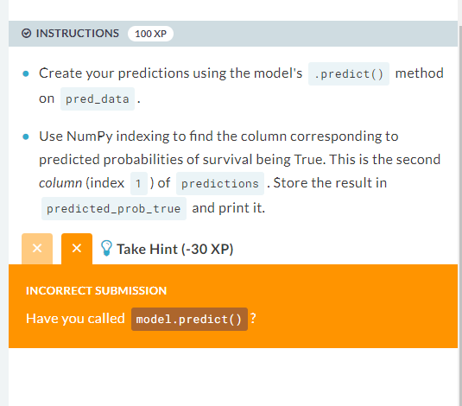

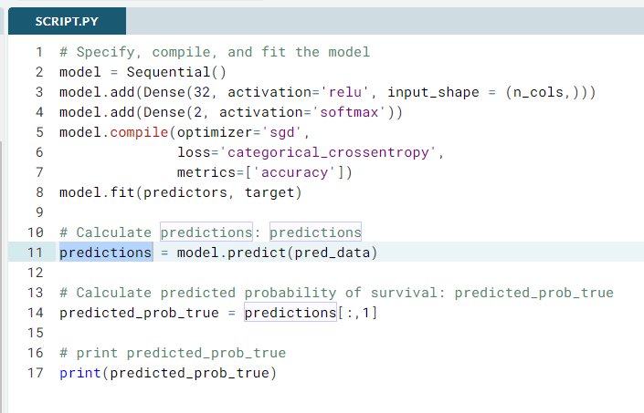

# Specify, compile, and fit the model

model = Sequential()

model.add(Dense(32, activation='relu', input_shape = (n_cols,)))

model.add(Dense(2, activation='softmax'))

model.compile(optimizer='sgd',

loss='categorical_crossentropy',

metrics=['accuracy'])

model.fit(predictors, target)

# Calculate predictions: predictions

predictions = model.predict(pred_data)

# Calculate predicted probability of survival: predicted_prob_true

predicted_prob_true = predictions[:,1]

# print predicted_prob_true

print(predicted_prob_true)

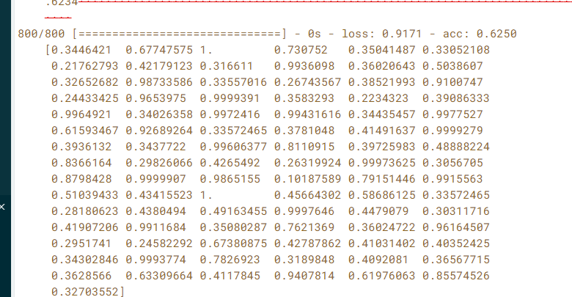

#### Fine-tuning keras models

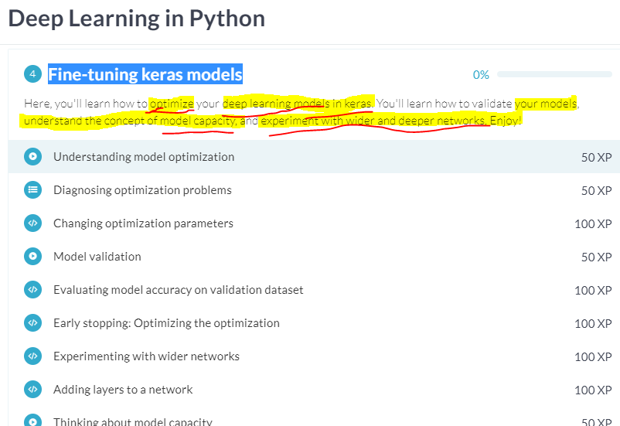

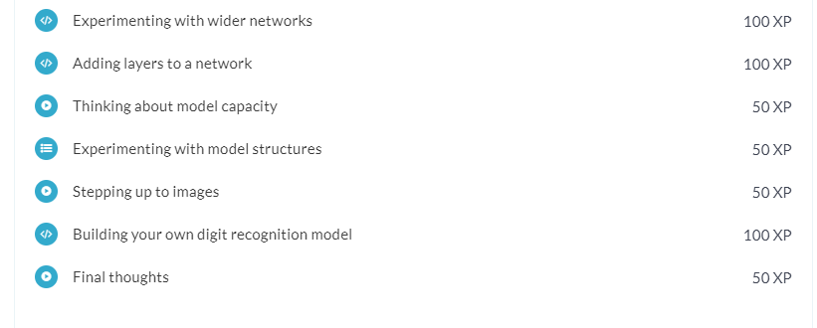

# Understanding model optimization

In practice, optimization is hard problem. The **optimal(saraina) value** for any one **weight depends on the value of the other weights**, and we are optimizing many weights at once

Even if the slope tells us which weights to increase, this to weight to decrease our **updates will not increase meaningfully.**

A **small learning rate** might cause us to make such small updates to model’s weights that out model doesn`t improve materially.

A **very large learning rate** might take us to far that seemed good.

**A smart optimizer like Adam helps, but optimization problem still occur.**

**The easiest way to see the effect of different learning rate is to use the simplest optimizer, Stochastic Gradient Decent, sometimes abbreviated to SGD, this optimizer uses a fixed learning rate**

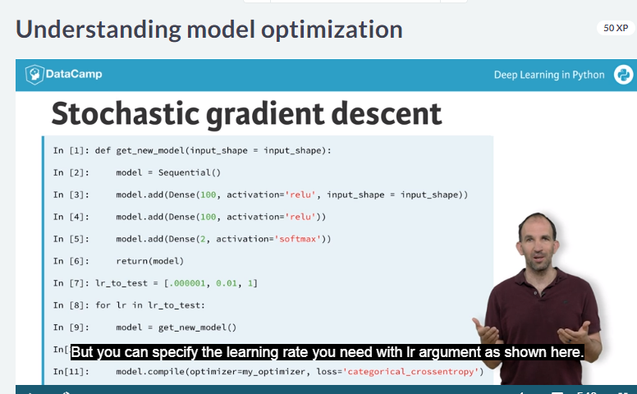

**We create models in a for loop, and each time around we compile the model using SGD with a different learning rate. We** pass in the optimizer with the same argument were we previously passed the string for **‘Adam’**

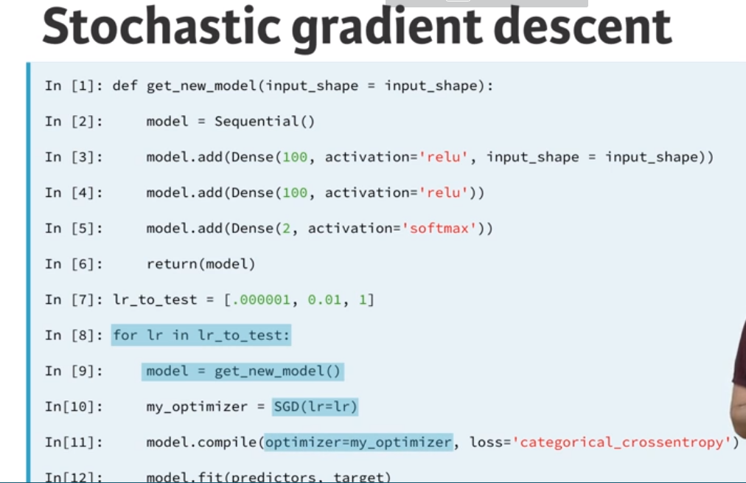

Even if the learning rate is well tuned, you can run into so called “dying-neuron” problem.

**Dying-Neuron**

This problem occurs when a **neuron takes a value less than 0** for all rows of data. Value produced an output of 0, and it has slope of 0.

Once **node getting negative input**, it may continue only getting negative input , contributing nothing to the model and hence claim that neuron is dead.

This might suggest using activation function whose slope is never exactly Zero

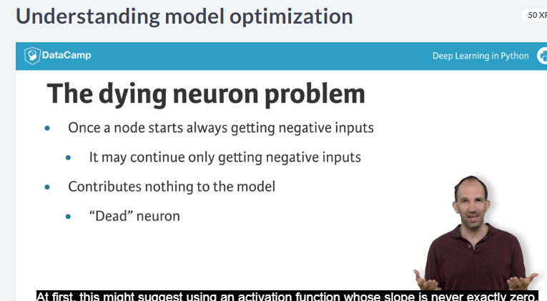

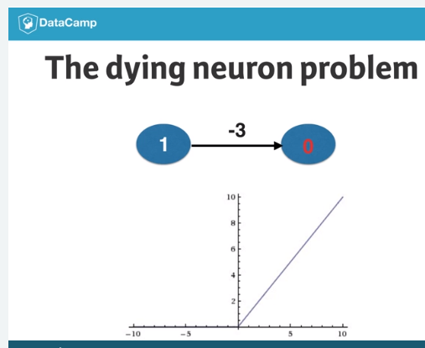

**Vanishing gradient**

A small but non-zero slope might work in a network with only a few hidden layer.

But in a deep network, one with many layer, the **repeated multiplication of small** slopes causes **the slopes to get close to zero**, which means updates in back propagation were close to zero this called the **vanishing gradient problem.**

**This in turn might suggest using an activation function that isn’t even close to flat** any where. If this happen, changing the activation function may be the solution

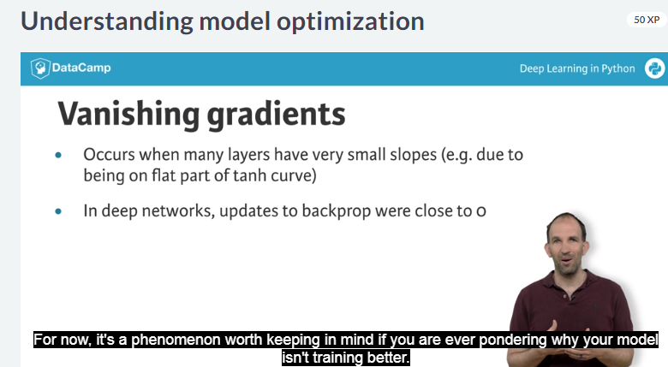

# Diagnosing optimization problems

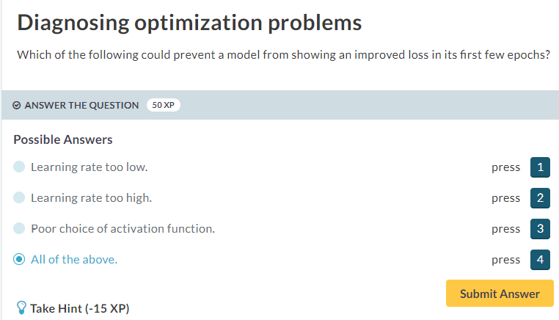



# Changing optimization parameters

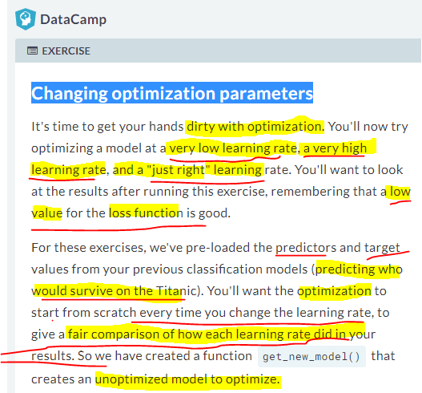

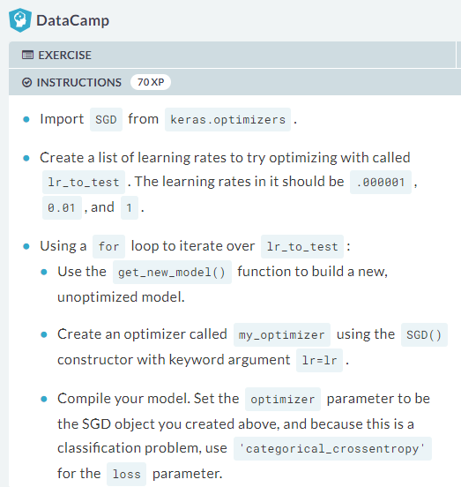

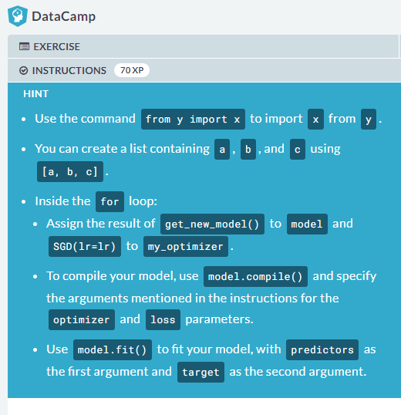

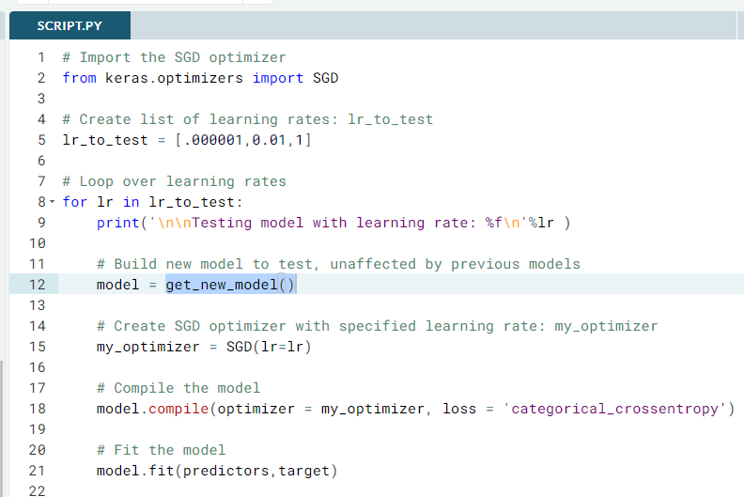

# Import the SGD optimizer

from keras.optimizers import SGD

# Create list of learning rates: lr_to_test

lr_to_test = [.000001,0.01,1]

# Loop over learning rates

for lr in lr_to_test:

print('\n\nTesting model with learning rate: %f\n'%lr )

# Build new model to test, unaffected by previous models

model = get_new_model()

# Create SGD optimizer with specified learning rate: my_optimizer

my_optimizer = SGD(lr=lr)

# Compile the model

model.compile(optimizer = my_optimizer, loss = 'categorical_crossentropy')

# Fit the model

model.fit(predictors,target)

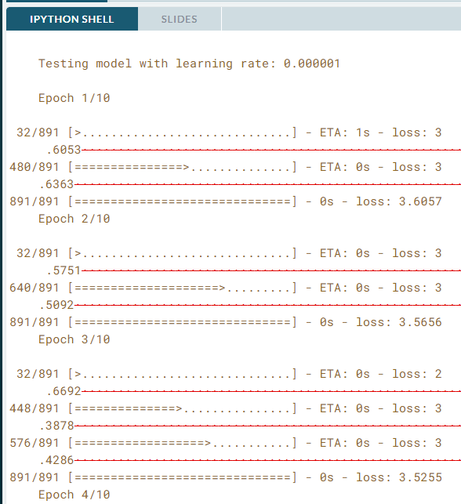

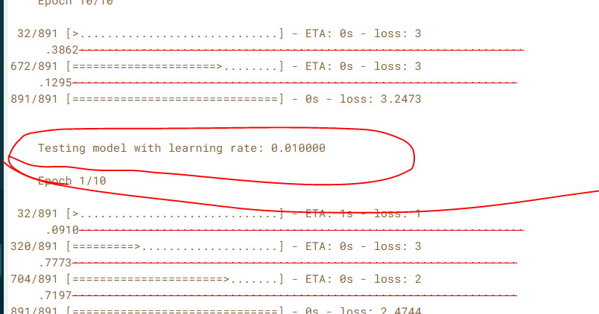

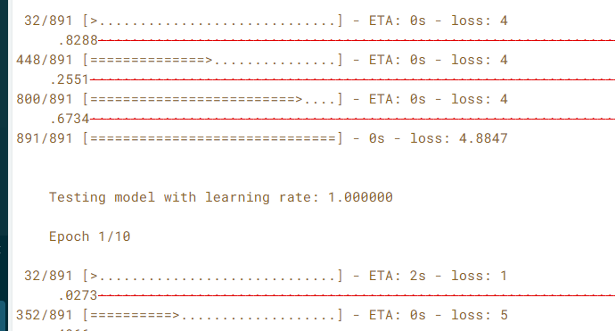

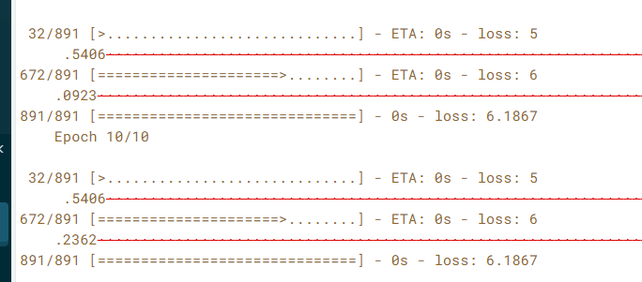

# Model validation

We use validation data to test model performance, validation data is the data that is explicitly held from training and used only to test the model performance

**Validation in deep**

In practice, few people run the k-fold cross validation on deep learning because deep learning typically uses on large data set

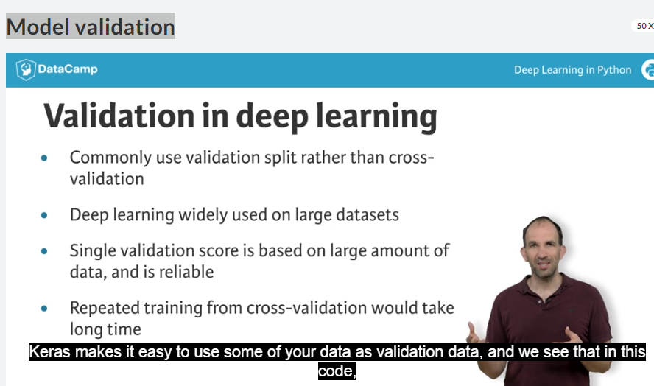

In fit method, we specify using the **keyword argument** ‘validation split’

In compile step, we specify **metrics = ‘accuracy’.**

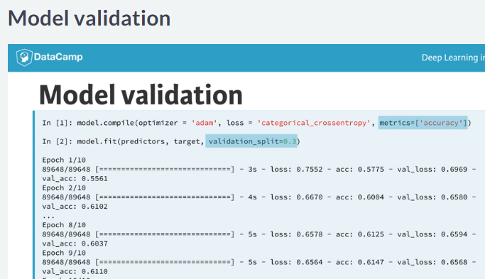

**Our goal is to have best validation score possible, so we should keep training while validation score is improving, and then stop training when the validation score is not improving**

**Early Stopping**

We do this with something called “Early stopping”.

We’ve imported something called **Early stopping**, we then create an “**Early stopping monitor**” before fitting the model.

That monitor takes an argument called **patience**, which is how many epochs the model can go without improving before we stop training.

2 or 3 are reasonable values for patience

But if you see 3 epochs with no improvement , it’s unlikely to turn and start improving

We will **pass early stopping monitor** to fit function under an argument called **callback** .

By default Keras trains for 10 epochs now that we have smart logic for determining when to stop, we can set a high maximum number of epochs.

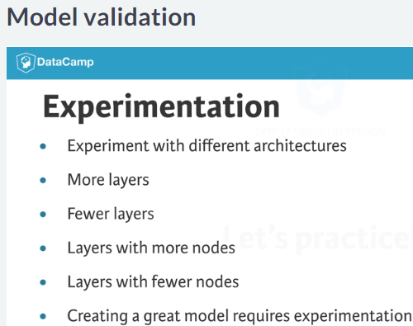

# Evaluating model accuracy on validation dataset

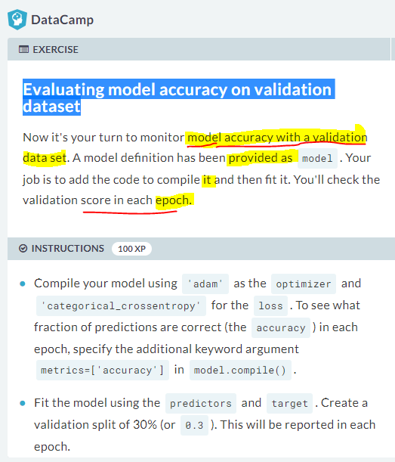

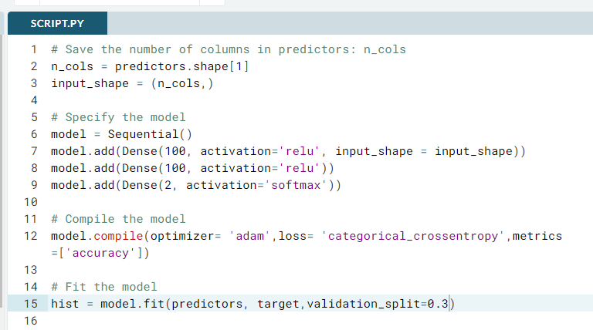

# Save the number of columns in predictors: n_cols

n_cols = predictors.shape[1]

input_shape = (n_cols,)

# Specify the model

model = Sequential()

model.add(Dense(100, activation='relu', input_shape = input_shape))

model.add(Dense(100, activation='relu'))

model.add(Dense(2, activation='softmax'))

# Compile the model

model.compile(optimizer= 'adam',loss= 'categorical_crossentropy',metrics=['accuracy'])

# Fit the model

hist = model.fit(predictors, target,validation_split=0.3)

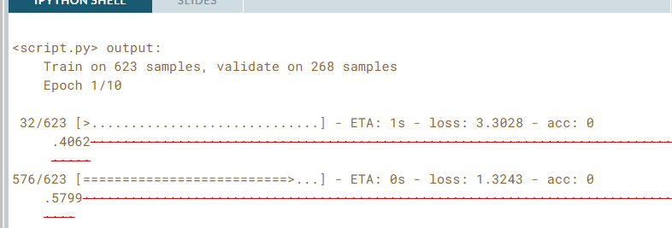

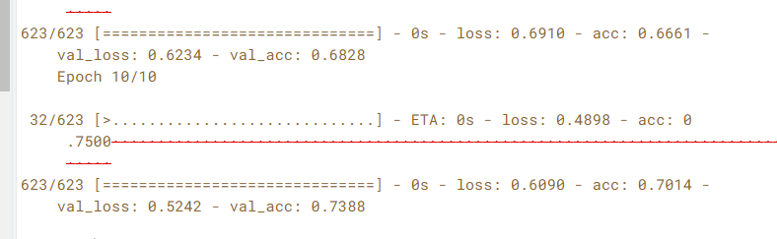

# Early stopping: Optimizing the optimization

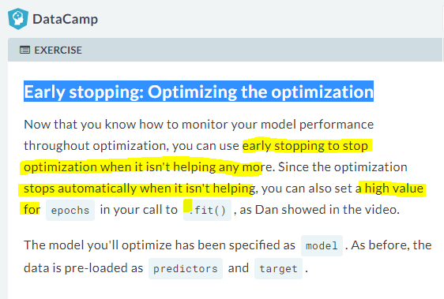

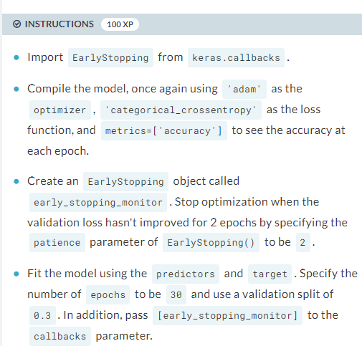

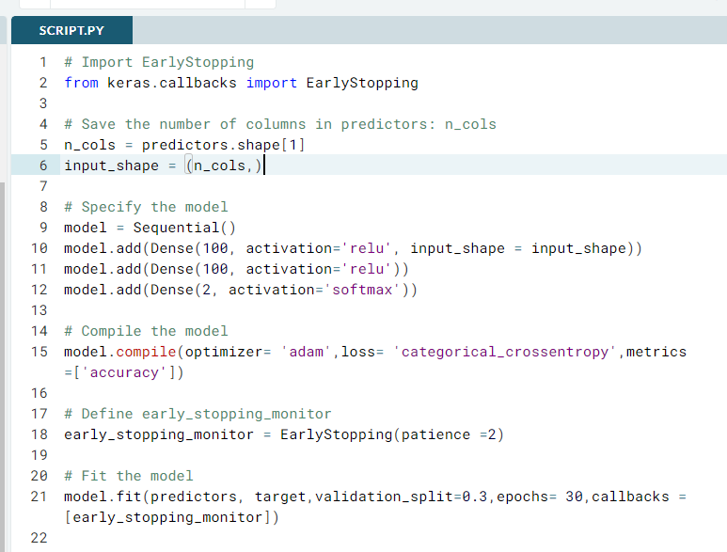

# Import EarlyStopping

from keras.callbacks import EarlyStopping

# Save the number of columns in predictors: n_cols

n_cols = predictors.shape[1]

input_shape = (n_cols,)

# Specify the model

model = Sequential()

model.add(Dense(100, activation='relu', input_shape = input_shape))

model.add(Dense(100, activation='relu'))

model.add(Dense(2, activation='softmax'))

# Compile the model

model.compile(optimizer= 'adam',loss= 'categorical_crossentropy',metrics=['accuracy'])

# Define early_stopping_monitor

early_stopping_monitor = EarlyStopping(patience =2)

# Fit the model

model.fit(predictors, target,validation_split=0.3,epochs= 30,callbacks = [early_stopping_monitor])

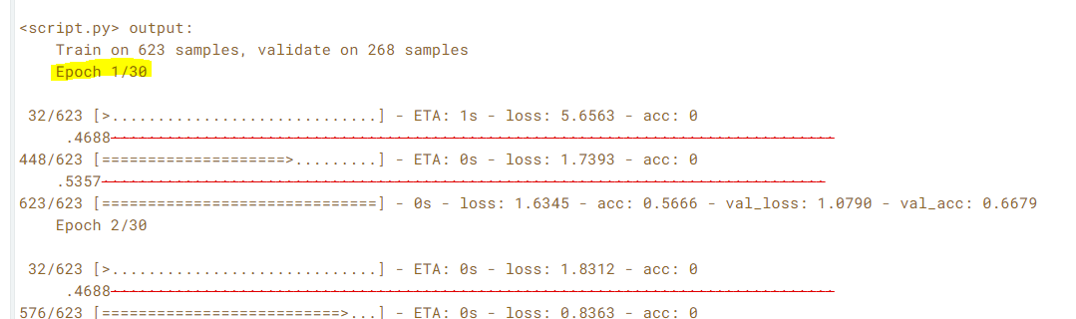

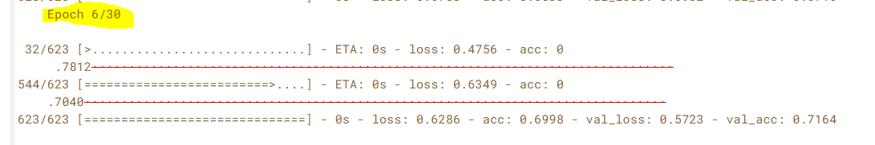

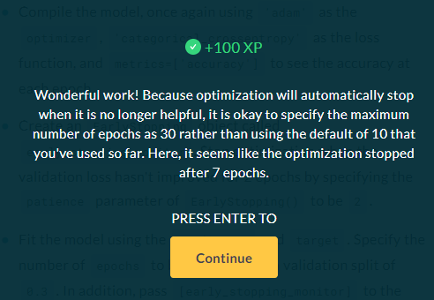

# Experimenting with wider networks

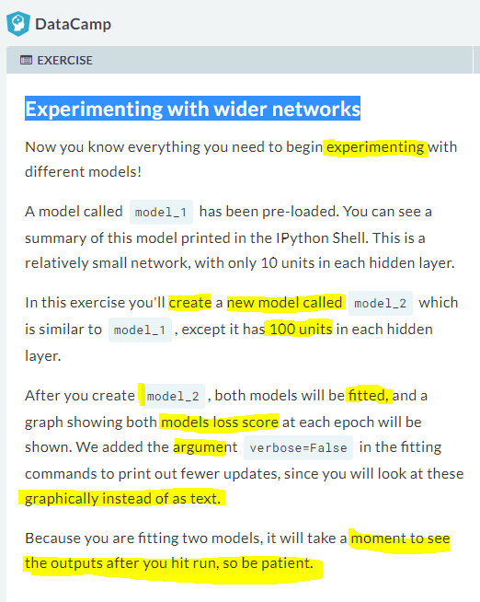

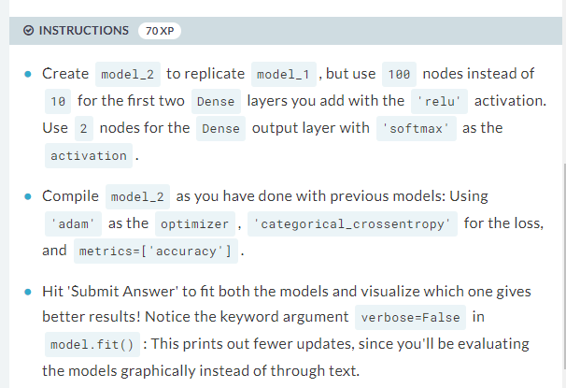

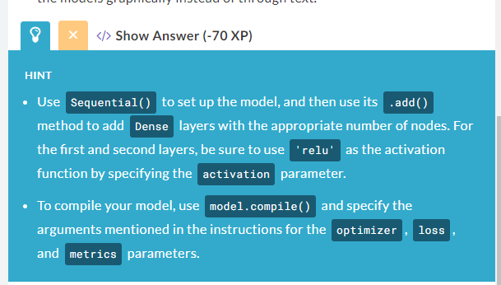

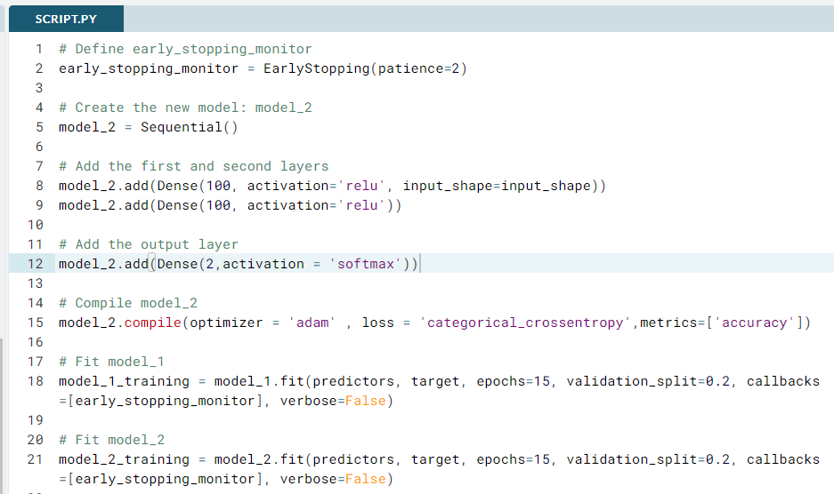

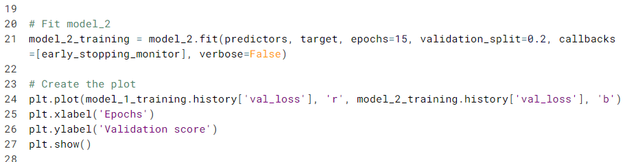

# Define early_stopping_monitor

early_stopping_monitor = EarlyStopping(patience=2)

# Create the new model: model_2

model_2 = Sequential()

# Add the first and second layers

model_2.add(Dense(100, activation='relu', input_shape=input_shape))

model_2.add(Dense(100, activation='relu'))

# Add the output layer

model_2.add(Dense(2,activation = 'softmax'))

# Compile model_2

model_2.compile(optimizer = 'adam' , loss = 'categorical_crossentropy',metrics=['accuracy'])

# Fit model_1

model_1_training = model_1.fit(predictors, target, epochs=15, validation_split=0.2, callbacks=[early_stopping_monitor], verbose=False)

# Fit model_2

model_2_training = model_2.fit(predictors, target, epochs=15, validation_split=0.2, callbacks=[early_stopping_monitor], verbose=False)

# Create the plot

plt.plot(model_1_training.history['val_loss'], 'r', model_2_training.history['val_loss'], 'b')

plt.xlabel('Epochs')

plt.ylabel('Validation score')

plt.show()

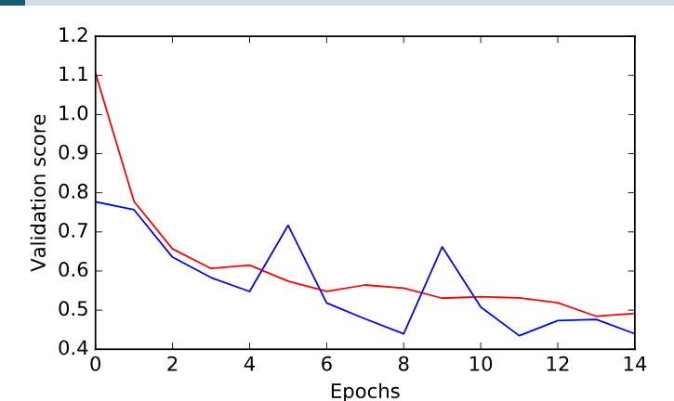

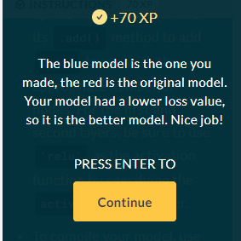

# Adding layers to a network

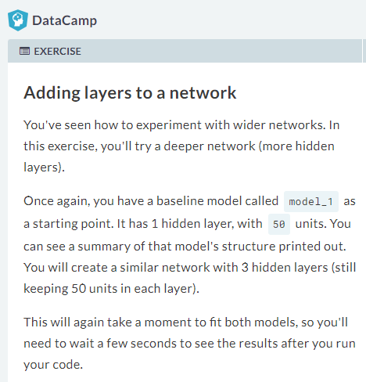

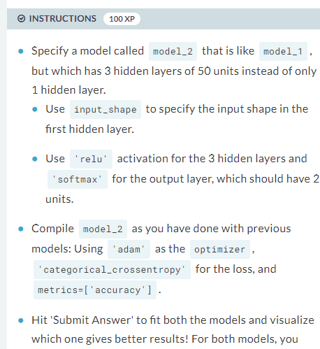

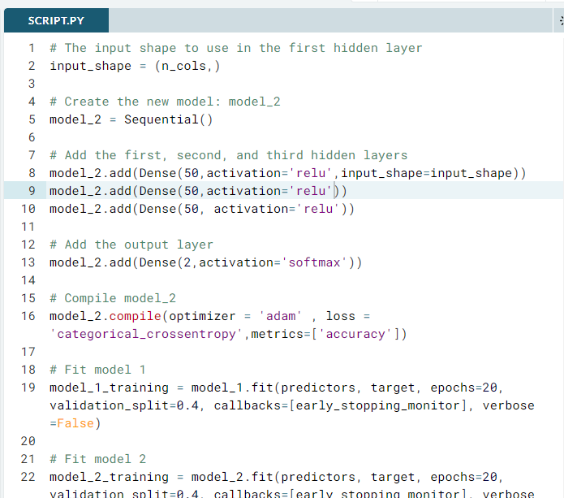

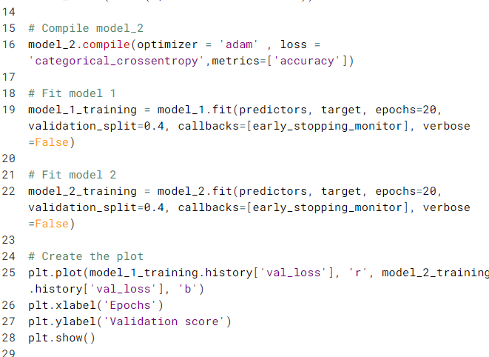

# The input shape to use in the first hidden layer

input_shape = (n_cols,)

# Create the new model: model_2

model_2 = Sequential()

# Add the first, second, and third hidden layers

model_2.add(Dense(50,activation='relu',input_shape=input_shape))

model_2.add(Dense(50,activation='relu'))

model_2.add(Dense(50, activation='relu'))

# Add the output layer

model_2.add(Dense(2,activation='softmax'))

# Compile model_2

model_2.compile(optimizer = 'adam' , loss = 'categorical_crossentropy',metrics=['accuracy'])

# Fit model 1

model_1_training = model_1.fit(predictors, target, epochs=20, validation_split=0.4, callbacks=[early_stopping_monitor], verbose=False)

# Fit model 2

model_2_training = model_2.fit(predictors, target, epochs=20, validation_split=0.4, callbacks=[early_stopping_monitor], verbose=False)

# Create the plot

plt.plot(model_1_training.history['val_loss'], 'r', model_2_training.history['val_loss'], 'b')

plt.xlabel('Epochs')

plt.ylabel('Validation score')

plt.show()

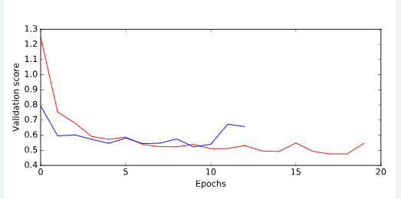



# Thinking about model capacity

Model capacity is a model’s ability to capture predictive patterns in your data. So , the more capacity a model, the further to the right we will be on this graph

If you had a network , **you increased the number of node** or neurons’ in a hidden layer that would **increase the model capacity** making larger layer or increasing the number of layer moves you further to the right of this graph

There is still a little more art to finding good deep learning, but sometimes called “**model capacity**” should be one of the key consideration you think about when deciding what model to try .

“**Model capacity**” or “**network capacity**” is closely related to the terms over fitting and under fitting.

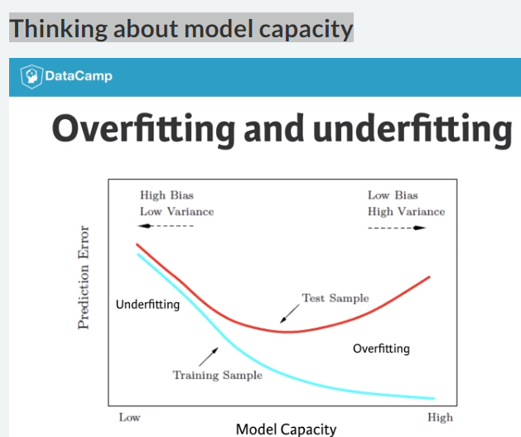

**Over fitting:**

Over fitting is the ability of a model to fit oddities in your training data that are there purely due to happenstance, and that won’t apply on new dataset

When you are over fitting, your **model will make accurate** **prediction on training data**, but it will make inaccurate predictions on validation data and new dataset.

**Under fitting:**

Under fitting is opposite that is when your model fails to find important predictive patterns in the training data. So it is accurate in neither the training data nor validation data.

We want to do well on new data set’s that weren’t used for training model, our validation score is the ultimate measure of model’s predictive quality.

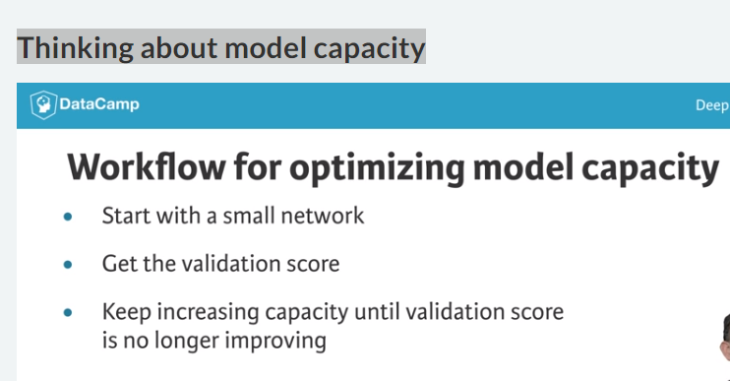

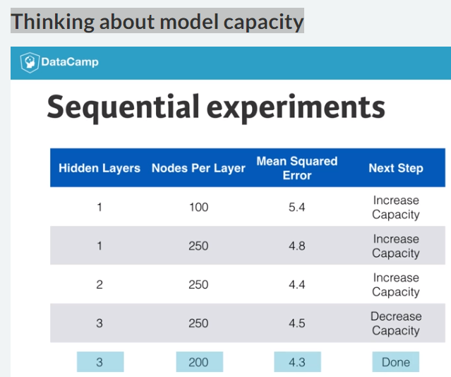

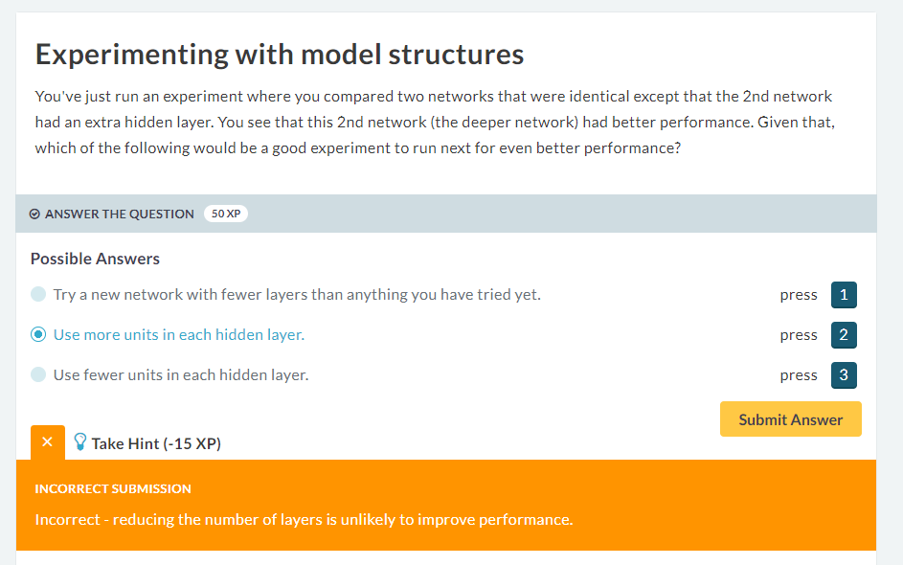



# Stepping up to images



# Building your own digit recognition model



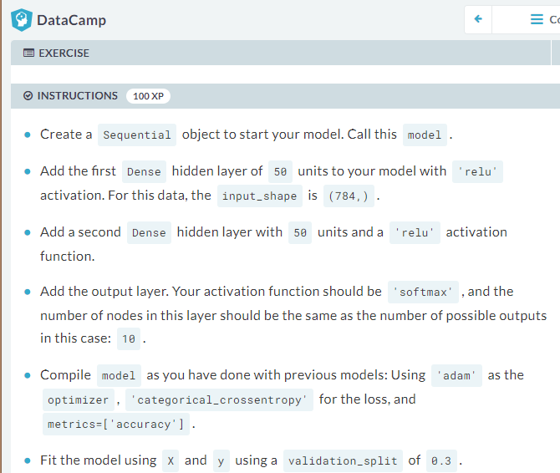

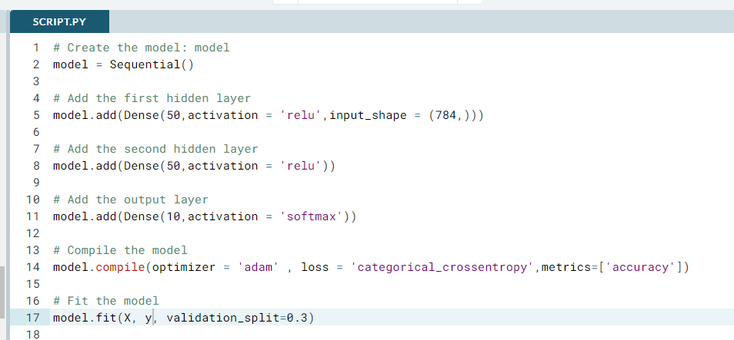

# Create the model: model

model = Sequential()

# Add the first hidden layer

model.add(Dense(50,activation = 'relu',input_shape = (784,)))

# Add the second hidden layer

model.add(Dense(50,activation = 'relu'))

# Add the output layer

model.add(Dense(10,activation = 'softmax'))

# Compile the model

model.compile(optimizer = 'adam' , loss = 'categorical_crossentropy',metrics=['accuracy'])

# Fit the model

model.fit(X, y, validation_split=0.3)